**Title: CITIZEN AI – INTELLIGENT CITIZEN ENGAGEMENT PLATFORM**

***MENTOR: K. RATNA KUMARI MADAM***

**TEAM ID: LTVIP2025TMID32708**

***TEAMLEADER: TUMMALAPUDI MANIKANTA***

** ROLLNO:SBAP0032708 MAIL ID:** [**manikantatummalapudi03@gmail.com**](mailto:manikantatummalapudi03@gmail.com)

**TEAM MEMBERS:**

**1)GUNDABATTULA LAKSHMI DURGA**

** ROLLNO:SBAP0032736 MAIL ID:** [**gtulasidurga9@gmail.com**](mailto:gtulasidurga9@gmail.com)

**2)MOHAMMAD ABDUL RASHAAD**

**ROLLNO:SBAP0032740 MAILID:**[**abdulrashaad1234@gmail.com**](mailto:abdulrashaad1234@gmail.com)

**3)PATNALA VENU MADHAVI**

**ROLLNO:SBAP0032744 MAIL ID:** [**madhaveevenu226@gmail.com**](mailto:madhaveevenu226@gmail.com)

**4)ADDALA DURGA PRASAD**

**ROLLNO:SBAP0032716 MAIL ID:** [**prasadnaidu293293@gmail.com**](mailto:prasadnaidu293293@gmail.com)

**Report of the Public Awareness Working Group**

2021-2022

**Publication information**

**Table of contents**

* [**List of acronyms and abbreviations**](https://ised-isde.canada.ca/site/advisory-council-artificial-intelligence/en/public-awareness-working-group/learning-together-responsible-artificial-intelligence#1)
* [**Key terminology**](https://ised-isde.canada.ca/site/advisory-council-artificial-intelligence/en/public-awareness-working-group/learning-together-responsible-artificial-intelligence#2)
* [**Message from the co-chairs**](https://ised-isde.canada.ca/site/advisory-council-artificial-intelligence/en/public-awareness-working-group/learning-together-responsible-artificial-intelligence#3)
* [**Executive summary**](https://ised-isde.canada.ca/site/advisory-council-artificial-intelligence/en/public-awareness-working-group/learning-together-responsible-artificial-intelligence#4)
* [**Introduction and background**](https://ised-isde.canada.ca/site/advisory-council-artificial-intelligence/en/public-awareness-working-group/learning-together-responsible-artificial-intelligence#5)
* [**Research findings**](https://ised-isde.canada.ca/site/advisory-council-artificial-intelligence/en/public-awareness-working-group/learning-together-responsible-artificial-intelligence#6)
  + [AI literacy](https://ised-isde.canada.ca/site/advisory-council-artificial-intelligence/en/public-awareness-working-group/learning-together-responsible-artificial-intelligence#6.1)
  + [Perceptions of AI: Where are the opportunities and sources of optimism? What are the concerns and challenges?](https://ised-isde.canada.ca/site/advisory-council-artificial-intelligence/en/public-awareness-working-group/learning-together-responsible-artificial-intelligence#6.2)
  + [Looking ahead: How much more do people in Canada want to know about AI?](https://ised-isde.canada.ca/site/advisory-council-artificial-intelligence/en/public-awareness-working-group/learning-together-responsible-artificial-intelligence#6.3)
  + [Barriers to engagement: Who we did (and did not) hear from](https://ised-isde.canada.ca/site/advisory-council-artificial-intelligence/en/public-awareness-working-group/learning-together-responsible-artificial-intelligence#6.4)
* [**Recommendations**](https://ised-isde.canada.ca/site/advisory-council-artificial-intelligence/en/public-awareness-working-group/learning-together-responsible-artificial-intelligence#7)
* [**Moving ahead**](https://ised-isde.canada.ca/site/advisory-council-artificial-intelligence/en/public-awareness-working-group/learning-together-responsible-artificial-intelligence#8)
* [**Acknowledgements**](https://ised-isde.canada.ca/site/advisory-council-artificial-intelligence/en/public-awareness-working-group/learning-together-responsible-artificial-intelligence#9)
* [**Working group members**](https://ised-isde.canada.ca/site/advisory-council-artificial-intelligence/en/public-awareness-working-group/learning-together-responsible-artificial-intelligence#10)
* [**References**](https://ised-isde.canada.ca/site/advisory-council-artificial-intelligence/en/public-awareness-working-group/learning-together-responsible-artificial-intelligence#11)
* [**Appendix**](https://ised-isde.canada.ca/site/advisory-council-artificial-intelligence/en/public-awareness-working-group/learning-together-responsible-artificial-intelligence#12)
  + [A. Views of Canadians on artificial intelligence: survey methodology](https://ised-isde.canada.ca/site/advisory-council-artificial-intelligence/en/public-awareness-working-group/learning-together-responsible-artificial-intelligence#A)
  + [B. Quantitative research instrument (English version)](https://ised-isde.canada.ca/site/advisory-council-artificial-intelligence/en/public-awareness-working-group/learning-together-responsible-artificial-intelligence#B)
  + [C. Open Dialogue: Artificial intelligence in Canada- deliberation schedule](https://ised-isde.canada.ca/site/advisory-council-artificial-intelligence/en/public-awareness-working-group/learning-together-responsible-artificial-intelligence#C)
  + [D. Open Dialogue: Artificial intelligence in Canada- use cases](https://ised-isde.canada.ca/site/advisory-council-artificial-intelligence/en/public-awareness-working-group/learning-together-responsible-artificial-intelligence#D)

**List of acronyms and abbreviations**

|  |  |
| --- | --- |
| **AI** | **Artificial intelligence** |
| **AIS** | **Artificial intelligence systems** |
| **CIFAR** | **Canadian Institute for Advanced Research** |
| **CIUS** | **Canadian Internet Use Survey** |
| **EDIA** | **Equity, diversity, inclusion and accessibility** |
| **The Council** | **The Government of Canada's Advisory Council on AI** |
| **The Working Group** | **The Public Awareness Working Group** |
| **ISED** | **Innovation, Science, and Economic Development** |
| **OECD** | **Organisation for Economic Co-operation and Development** |
| **The Strategy** | **The Pan-Canadian Artificial Intelligence Strategy** |

**Key terminology**

**Artificial intelligence (AI)**

There is no single agreed-upon definition of AI. The OECD defines AI as "a machine-based system that can, for a given set of human-defined objectives, make predictions, recommendations, or decisions … designed to operate with varying levels of autonomy,"[Footnote1](https://ised-isde.canada.ca/site/advisory-council-artificial-intelligence/en/public-awareness-working-group/learning-together-responsible-artificial-intelligence#fn1) and describes the various steps involved in the lifecycle of an AI system, such as designing models and verifying results. This definition is broad and encompasses a wide variety of possible AI techniques and application, but is designed for policy recommendations, rather than interpretation by the general public. A plain-language adaptation of this general definition was necessary, so for the purpose of the survey research, AI was defined for participants as follows:

**"AI is the set of computer techniques that enable a machine (e.g., a computer or mobile telephone) to perform tasks that typically require intelligence, such as reasoning or learning."**

In the deliberation guide shared online with participants and interested members of the public in the 'Open Dialogue: Artificial Intelligence in Canada' workshops, this is expanded:

**"AI is the set of computer techniques that enable a machine (e.g., a computer or telephone) to perform tasks that typically require intelligence, such as reasoning or learning. It is also referred to as the automation of intelligent tasks. Scientific developments in AI, such as deep-learning techniques, have made it possible to design access to huge amounts of data and ever-increasing computing power. These new techniques have been rapidly deployed on a large scale in all areas of social life, in transport, education, culture and health."**[**Footnote2**](https://ised-isde.canada.ca/site/advisory-council-artificial-intelligence/en/public-awareness-working-group/learning-together-responsible-artificial-intelligence#fn2)

**AI literacy**

Literacy in a subject reflects the knowledge and skills required to enable individuals to express, communicate, and critique the ideas of the field. However, which skills and knowledge are considered essential depends on the priorities of those in positions of authority in that field. Therefore, we grounded our assessment tools in a broader definition developed by Long and Magerko that frames AI literacy through a more holistic lens:

**"AI Literacy is a set of competencies that enables individuals to critically evaluate AI technologies; communicate and collaborate effectively with AI; and use AI as a tool online, at home, and in the workplace.**"[Footnote3](https://ised-isde.canada.ca/site/advisory-council-artificial-intelligence/en/public-awareness-working-group/learning-together-responsible-artificial-intelligence#fn3)

This broad definition allows for an understanding that literacy goes beyond simply a fundamental understanding of how the technology works to include knowledge of how this technology connects with a variety of social, ethical, economical, and policy issues.

**Deliberation**

Deliberation is a rational discussion through an exchange of arguments for a collective decision with the goal to increase the knowledge of each participant and allow for a better understanding of individual and collective interests. It can alter our initial preferences. It does not necessarily lead to consensus, but rather to the identification of common orientations based on convergences and divergences of opinion and the reasons behind them.

**Participants**

Throughout the report, "participants" is used to refer to the population who participated in the Open Dialogue: Artificial Intelligence in Canada. This includes both the adult participants (18+) and youth participants (14-17 years old) who were defined based on their physical residency within Canada.

**People living in Canada**

Early in the process of defining the activities of the Working Group, the choice was made to consciously reject the use of terms such as "Canadian citizen" or "Canadian" to define our target population. As these terms inadequately convey the relationship between Indigenous peoples and Canada, and are sometimes used to exclude marginalized populations, "people living in Canada" is used instead.

**Respondents**

Throughout the report, "respondents" is used to refer to the survey population. While reflective of people living in Canada's national age, gender, and geographic diversity by province, the survey population is non-representative of ethnocultural, educational, or income diversity.

**Youth**

For the purposes of the 'Open Dialogue: Artificial Intelligence in Canada' workshop series, youth was defined as between the ages of 14-17.

**Message from the co-chairs**

Artificial Intelligence (AI) is gaining importance in nearly every sector of the Canadian economy. It is rapidly advancing in sophistication and integration in our daily lives. While AI presents many opportunities for people in Canada, the fast development of AI technologies often outpaces the ability of the Canadian public to remain aware of AI advancements, and to identify the promises and risks of this new and evolving technology.  We need look no further than the recent example of the large deep learning models ChatGPT and DALL-E 2, which generate sophisticated prose or images, respectively, from simple prompts by a human user.  These powerful approaches have captured the attention of innovators, policymakers, and the public at large for their demonstration of both the opportunity to generate novel and beneficial applications of AI and the potential for misuse.

Acknowledging this gap, and mindful that AI adoption is dependent on public trust, the Government of Canada launched a Public Awareness Working Group in 2020 as a means of listening to and informing citizens in the context of this rapidly evolving Canadian AI ecosystem. Media discourse on AI to date has typically focused on optimism and fear, while sometimes overstating the capabilities of AI. Baseline data had not been gathered about what people in Canada currently know about AI, what they are hopeful and optimistic about, and what ideas about AI dominate their fears or concerns.

The Working Group began with a mandate to examine avenues to boost public awareness and foster trust in AI. The objective was to help Canadians have a more grounded conversation on AI, and to help citizens better understand the technology, its potential uses, and associated risks. The Working Group was committed to including all people living in Canada, regardless of their citizenship status, and engaging all groups and communities that comprise Canada's population. We took steps to reach out to participants beyond the stakeholders that are already engaged in dialogues on AI.

We designed and deployed a national survey followed by an ambitious pan-Canadian deliberative process, the Open Dialogue: Artificial Intelligence in Canada, holding virtual workshops with residents, including youth, from coast to coast. We undertook these efforts during the second and third waves of the COVID-19 pandemic, which presented numerous challenges and necessitated an entirely virtual engagement. We recognize that we faced understandable constraints that impacted our ability to achieve robust and diverse representation in both the survey and Open Dialogue. However, we learned a great deal during the execution of these plans, and this report contains recommendations about how diversity and inclusion could be better addressed in future engagement initiatives, some of which are already under way, ensuring meaningful engagement with the goal of democratizing the conversation about responsible, trustworthy AI.

This Working Group report should not be read as comprehensive or all-encompassing. Instead, it is a snapshot in time, reflecting the attitudes, knowledge and viewpoints of a portion of the Canadian population. Moreover, it is only a starting point for future engagements. We include a series of tangible and fundable recommendations that can be built upon to successfully engage people in Canada, build comprehensive public awareness about AI, and cultivate a society that is equipped with sufficient knowledge to think critically about new technologies. We emphasize that equity, diversity, inclusion, and accessibility must be at the forefront of all future initiatives.

We hope that the lessons learned, in both how the insights were gathered and what was shared by participants, will serve to inspire future public engagement efforts on AI in Canada.

**Catherine Riddell, Co-Chair of the Public Awareness Working Group (2020-21)**

**Marc-Antoine Dilhac, Co-Chair of the Public Awareness Working Group (2020-present)**

**1. Executive summary**

**Artificial intelligence: a transformative technology**

The growth of powerful, rapidly developing, and increasingly ubiquitous Artificial Intelligence (AI) systems and technologies is expected to affect every economic sector across Canada over the next ten years. The capabilities of AI technologies to predict, automate, analyze, and optimize provides substantial opportunities to help address some of the most challenging problems facing people across Canada, from improving healthcare and health outcomes to addressing climate change. AI also shapes and informs our everyday lives in ways ranging from personalized advertising recommendations to answering questions as your virtual smartphone assistant.

There are real opportunities for Canada to capitalize on its early AI leadership and create significant economic and social benefits stemming from the responsible development and application of these technologies. However, as AI technologies become increasingly pervasive and their usage more widespread, the risks and challenges become increasingly apparent. Questions regarding ethical development and deployment, including algorithmic bias and transparency, privacy and security, consumer protection, and automation-related job losses continue to play leading and critical roles in the Canadian public discourse on AI.

**Engaging on AI in Canada: conversations and key insights**

Canada has developed world-class AI expertise through early and sustained investments in talent, education, and research, including through the Pan-Canadian Artificial Intelligence Strategy which launched in 2017. The Government of Canada also launched the [Advisory Council on Artificial Intelligence](https://ised-isde.canada.ca/site/advisory-council-artificial-intelligence/en) (the Council) in 2019, with a mandate to identify opportunities for economic growth while promoting an ethical approach to AI grounded in human rights, transparency, and openness. Recognizing the importance of engaging people in Canada in dialogue on the opportunities, risks, and challenges of broader AI adoption, the Council launched the [Public Awareness Working Group](https://ised-isde.canada.ca/site/advisory-council-artificial-intelligence/en/public-awareness-working-group) (the Working Group) in 2020 to identify methods and strategies for sustained and effective public awareness and engagement on AI.

With a mandate to provide recommendations to the Council, the Working Group undertook its research with the goal of listening to, and engaging with, people in Canada in a dialogue on AI. The goals of this dialogue were to understand current levels of interest and awareness of AI in Canada, understand the public's perception of the technology and its potential applications, and identify initiatives and infrastructure required to support sustained and effective public awareness and engagement.

To effectively fulfil its mandate, the Working Group developed a three-fold engagement process to advance the conversation with people in Canada:

1. A **national survey** to determine a benchmark level of AI literacy and develop an understanding of the hopes and fears held by people in Canada towards AI and AI systems;
2. A **series of online workshops** aimed at engaging people in Canada, including youth, from across the country on the responsible development of AI through the discussion of hypothetical use cases; and,
3. A **report for the Council** that provides recommendations for the Government of Canada to effectively engage with people in Canada on AI on an ongoing and sustained basis.

**Understanding perceptions of AI: engaging with the people of Canada**

In November 2020, the Working Group launched an online survey developed with the assistance of Nanos Research. The survey engaged more than 1,200 Canadians drawn from a non-probability panel on three key themes: 1) assessing **AI literacy**; 2) identifying **areas of AI hope** or optimism; and 3) identifying **areas of AI fear** or concern. Later, in the spring of 2021, the Working Group rolled out the 'Open Dialogue: Artificial Intelligence in Canada', a series of 19 virtual workshops delivered in both French and English. Launched in partnership with the Canadian Institute for Advanced Research (CIFAR) and Algora Lab at the University of Montréal, these pan-Canadian workshops engaged 437 adults and youth across Canada, including 149 secondary school students, to share their views and advice on AI adoption through the discussion of a variety of prospective use cases.

The results of the survey and the online workshops were illuminating. Broadly, self-reported AI literacy was high among survey and workshop participants, with survey respondents reporting their knowledge was primarily gained from online sources and news media as opposed to traditional educational sources (i.e., schools, work training/upskilling programs, etc.). Participants in the deliberations noted the need to consider the growth of AI literacy in two separate but complementary realms, urging that AI awareness initiatives must consider not only the fundamentals of AI systems, but also the additional awareness to engage on the social, economical, ethical, and political elements of AI.

Likewise, the perception of AI and its impacts was also a key factor to consider in the development of awareness campaigns. Although sample populations were largely positive about the perceived social benefits of AI across both the national survey and the workshops, this sentiment changed with context. Respondents often moderated their optimism when they were challenged to transition their thinking from generalized application concepts towards personal or familiar assessments of AI systems, across such realms as policing, justice, and health.

Finally, the survey and workshops revealed the common theme that most participants were greatly in favour of enhancing and expanding education opportunities on AI, particularly those that teach responsible usage and critical assessment. Participants highlighted a range of potential actions to provide AI-related education opportunities, including social and traditional media campaigns as well as curated and trustworthy AI educational learning opportunities.

**"AI awareness initiatives must consider not only the fundamentals of AI systems, but also the additional awareness to engage on the social, economical, ethical, and political elements of AI."**

In arriving at these results and observations, the Working Group acknowledges the presence of various limitations in the first two tracks of research. For example, given that the Open Dialogue workshops were open to the public without screening criteria in place, the Working Group found that the self-selected participants typically had university-level education at a rate that exceeded the general population of Canada.

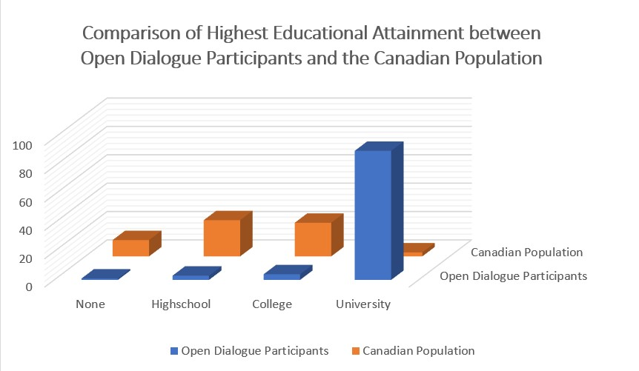

Figure 1. Comparison of the highest level of educational attainment reported by participants in the general population sessions of the Open Dialogue: Artificial Intelligence in Canada workshops to the results of the 2016 Canadian Census.[Footnote4](https://ised-isde.canada.ca/site/advisory-council-artificial-intelligence/en/public-awareness-working-group/learning-together-responsible-artificial-intelligence#fn4)

Figure 1 – Text version

Furthermore, and by nature of their participation, workshop participants were able to contribute several hours of their time to these online consultations. In the survey, targeted population sampling—which would include ensuring sufficient sampling to report on ethnocultural and generational diversity, Indigenous peoples, and persons with disabilities—and non-web methods such as telephone survey delivery were beyond the resources and scope of this initial effort of the Working Group, although targeted engagement remains an area the Working Group is pursuing. This resulted in the data collected being limited to gender, age (over 18 due to constraints of the vendor) and geographic representativeness due to insufficient response numbers from other demographic categories.

As a result, the Working Group notes future consultations must include more focused and deliberate outreach to under-consulted populations, including those most likely to be affected by AI technologies and systems. The lack of representation by these populations is a significant limitation of the Working Group's findings. The Working Group requested and received Council approval to continue their AI awareness work using a long-term and inclusive approach, that would specifically target participation from marginalized, under-represented, under-consulted, and Indigenous communities.

Recognizing these stated limitations, the Working Group has arrived at a series of recommendations that it believes will ground the discourse in Canada in a measured understanding of AI technology, its potential uses and its associated risks, and how engagement and dialogue with people across Canada must be central to the future development and deployment of responsible AI in Canada.

**An ongoing dialogue: recommendations for increasing AI awareness and engagement in Canada**

Broadly, these recommendations would first urge the Government of Canada to take a leadership role in the creation, curation, and dissemination of AI resources for the express benefit of all people in Canada to improve their understanding of AI systems. Specifically, the Working Group believes this can be accomplished through:

1. **Creating a national AI Community of Practice**, which would provide an open repository of AI dialogue resources and best practices for researchers, community leaders, policy makers, and the general public to engage in an ongoing dialogue on the responsible and ethical development, use, and governance of AI technologies.
2. **Leveraging existing initiatives and programs to better promote, benchmark and measure AI awareness** and provide equal opportunity for access and participation in the dialogue. For example, the Government of Canada regularly conducts surveys of Canadians on technology-related issues, such as through the Canadian Internet Use Survey (CIUS).[Footnote5](https://ised-isde.canada.ca/site/advisory-council-artificial-intelligence/en/public-awareness-working-group/learning-together-responsible-artificial-intelligence#fn5) The Government could work to ensure that AI literacy and awareness questions are included in future iterations of this Survey.
3. **Facilitating the creation, endorsement and promotion of a free, online AI literacy course** designed to increase general technical AI literacy, develop informed public opinions about AI and its implications, and empower marginalized communities with technological literacy.
4. **Engaging people in Canada in meaningful public dialogues** to understand what applications and uses of AI are in alignment with the public interest and goals of the impacted communities. These dialogues would be undertaken with the intent to co-develop AI policy that addresses these hopes and fears, builds public confidence in the use and governance of the technology, and both enables and limits AI deployment, so it aligns with the interests of diverse communities.
5. **Launching sustained and government-led public information campaigns** across traditional and social media to promote the knowledge of and participation in resources initiatives such as the AI Awareness Community of Practice and the AI literacy course, as well as future public consultations.
6. Funding an **Equity, Diversity, Inclusion, and Accessibility strategy** for the next ten years to support public engagement initiatives to ensure the financial, accessibility, and outreach resources are available to enable representation of the diversity of peoples in Canada. The dedication of sufficient resource support, time, and pre-developed relationships with communities is a critical determinant to the ability of future programs and engagement to bridge the gap to achieve the necessary inclusion and diversity.
7. Ensuring **access to high-speed internet across Canada**. This is a key determinant in ensuring access to and awareness of AI systems; the Working Group encourages Canada to continue and intensify its efforts to bring affordable high-speed internet to all people in Canada.
8. **Promoting the value and necessity of engagement with citizens** as a key pillar in advancing the responsible development of AI technologies. This would reflect the plurality of knowledge sources in the co-construction, co-creation processes that may be used, through platforms and initiatives such as the Global Partnership on AI, the AI Impact Alliance, the Montréal Declaration on Responsible AI, and the partnership between CIFAR and the International Development Research Centre (IDRC).

**Leadership in AI engagement: opportunities for the Government of Canada to help build an inclusive digital future**

The report of the Working Group is a call to action for governments and people in Canada alike. The Working Group believes that sustained and long-term engagement and dialogue opportunities provided by or delivered on behalf of the Government of Canada are critical in advancing the conversation on the hopes, risks, and fears of widespread AI technology adoption. The Government of Canada has the resources not only to help drive this conversation, but also to widen the discourse through targeted engagement to marginalized and under-consulted communities that are likely to be significantly impacted by AI systems. Likewise, the Working Group calls on all residents of Canada to engage in AI education, awareness and literacy, in order to ensure that AI technologies reflect our common values, democratic processes and institutions.

As the Working Group looks ahead to the next phase of its work, we note the importance of pursuing our recommendations with a priority focus on integrating a diversity, equity, accessibility, and inclusion lens at each stage. Key to this renewed focus is a commitment to listening to the needs of Indigenous Peoples and exploring opportunities of co-development and shared leadership. Through the prioritized development of culturally appropriate and relevant resources for Indigenous dialogues on AI, the Working Group aims to ensure that the omission of Indigenous consultation is not replicated in work going forward, and that future consultations benefit from the inclusion of Indigenous voices and knowledge.

**2. Introduction and background**

**2.1 Introduction**

Artificial intelligence (AI) is expected to affect or transform every sector and industry in Canada. AI has the power to help us address some of our country's most challenging problems, from improving healthcare and health outcomes to addressing climate change. It will also introduce new sources of job creation and sustainable economic growth. Yet many worry that the rapid pace of AI development and adoption is outpacing our ability to understand and manage the impact of AI on society and the economy. The increasing use of AI has brought a host of new risks and challenges into the spotlight. Around the world, citizens are raising questions about AI's impact on privacy, security, discrimination and bias, consumer protection, and more. As the deployment of AI increasingly affects all spheres of personal, professional, and social life, it is crucial to expand our ability to critically understand, assess, and engage with AI beyond scientists to citizens, users, and those in our society most affected by it.

Through early and sustained investments in fundamental research over more than three decades, Canada has developed world-leading expertise in machine learning, deep learning, and reinforcement learning that has positioned our country to be a global leader in its responsible development. In 2017, the Government of Canada secured this position with the creation of the Pan-Canadian Artificial Intelligence Strategy (the Strategy), supported by a $125 million investment, to sustain and expand the AI research and education ecosystem and maintain Canada's competitive position in this rapidly developing field.[Footnote6](https://ised-isde.canada.ca/site/advisory-council-artificial-intelligence/en/public-awareness-working-group/learning-together-responsible-artificial-intelligence#fn6) Led by the Canadian Institute for Advanced Research (CIFAR), the Strategy aimed initially to attract and retain world-class research talent in AI, drive innovation and research collaborations, and enhance Canada's international profile as a destination for financial investment. The Strategy supports a national program of research chair positions in AI at three national institutes: the Vector Institute in Toronto; Mila in Montréal; and the Alberta Machine Intelligence Institute (Amii) in Edmonton. The Institutes conduct world-class research and training activities to attract and develop further talent, and act as regional and national hubs for the Canadian AI communities, including the industry and innovation communities. Funding also supports research and innovation, led by CIFAR, to develop global thought leadership on the economic, ethical, political, and legal implications of advances in AI.

In 2021, the Government of Canada pledged to renew and expand the Strategy with an additional investment of up to $443.8 million.[Footnote7](https://ised-isde.canada.ca/site/advisory-council-artificial-intelligence/en/public-awareness-working-group/learning-together-responsible-artificial-intelligence#fn7) This renewed Strategy would continue supporting the attraction and retention of top academic talent, as well as a renewal of CIFAR research, training, and knowledge mobilization programs. The additional funding would also help support the commercialization of AI innovations and research in Canada, as well as both provide dedicated computing capacity for researchers at the Institutes and advance the development and adoption of AI standards.

Recognizing that success in AI adoption and innovation cannot be achieved through investments alone, the Government of Canada launched an [Advisory Council on Artificial Intelligence](https://ised-isde.canada.ca/site/advisory-council-artificial-intelligence/en) (the Council) in 2019. Composed of researchers, academics, and business leaders, the Council is mandated to advise the Government of Canada on how best to build on Canada's AI strengths, to identify opportunities to create inclusive and sustainable economic growth that benefits all Canadians, and to ensure that AI advancements reflect Canadian values. The Government asked the Council to address a human-centric approach to AI, grounded in human rights, transparency, and openness, with an aim to not only increase trust and accountability in AI, but to also protect our democratic values, processes, and institutions.

In support of this mandate, the Council launched the [Public Awareness Working Group](https://ised-isde.canada.ca/site/advisory-council-artificial-intelligence/en/public-awareness-working-group) (the Working Group) in early 2020 with the responsibility of engaging with and listening to people in Canada to understand current levels of interest, perceptions around, and awareness of AI in Canada, as well as to identify considerations on best practices for sustained and effective public awareness and engagement. Recognizing the value of an open dialogue with people in Canada, the Working Group was mandated to develop inclusive strategies to boost public awareness and foster trust in responsible development, use and governance of AI systems, undertake research to understand the public's perception of the technology and its potential applications, and identify initiatives and infrastructure required to support sustained and effective public awareness and engagement.

This research conducted by the Working Group serves to support the Advisory Council's mandate to advise the Government of Canada on how best to build on Canada's AI strengths, identify opportunities to create economic growth that benefits all Canadians and ensure that AI advancements reflect Canadian values, as set out in [Canada's Digital Charter](https://ised-isde.canada.ca/site/innovation-better-canada/en/canadas-digital-charter-trust-digital-world). To establish an evidence-based standard of the current public perception of AI and its development, this work supports the goal of grounding the Canadian discourse in a measured understanding of the technology, its potential uses, and its associated risks. To that end, the Working Group's research centred on the examination of three main themes:

1. **Assessing AI Literacy:** Understand what Canadians know about capabilities, limitations and use of AI, its potential, strengths, and limitations; as well as concepts such as human design, machine learning, and basic digital literacy. This research theme aimed to establish a baseline of participants' familiarity with AI and allow researchers to assess gaps in basic knowledge and identify issues of inclusivity and potential barriers to knowledge acquisition.
2. **Identifying Perceptions of Hope and Opportunity related to AI:** Identify the areas in which Canadians see the greatest potential and benefit from AI technologies for them personally, in their lives and work, and for society.
3. **Identifying Areas of Concern, Fear or Challenge related to AI:** Identify issues and areas of concern or fear Canadians may hold related to AI, including privacy, identity, security, and impact on the workforce.

Through conducting this research, the activities of the Working Group serve to help further the Government of Canada's international and national commitments to advance the goals laid out in the [Canada-France Statement on Artificial Intelligence](https://www.international.gc.ca/world-monde/international_relations-relations_internationales/europe/2018-06-07-france_ai-ia_france.aspx?lang=eng): specifically, fostering innovation while building trust in digital societies and economies, and promoting a human-centric approach to AI grounded in human rights, inclusion, equity, diversity, transparency and openness, sustainability, and economic growth.

**2.2 Mandate and purpose**

Recalling the goal of the Working Group to explore and recommend mechanisms to boost public awareness and foster trust in AI, the scope of the Working Group was limited to three key areas:

1. **Develop regional approaches for engaging the public**, provinces, territories, and municipalities, with consultations launched in early 2021.
2. **Conduct a dialogue with people living in Canada** to identify opportunities and risks of deploying AI technologies (e.g., perceived intention; responsible use grounded in ethical principles and human rights; data protection; adapting to increased automation).
3. **Provide a report** on engagement activities and recommend opportunities for sustained public engagement.

Members of the Working Group were guided by this scope, with the inherent understanding of the need to involve people in Canada comprehensively and purposefully in defining the future for the responsible use of AI. From its initial discussions, the Working Group acknowledged that comprehensive engagement necessarily requires reflecting the diversity of Canada in the people consulted and included in the research. While this broader engagement was not realized in this stage of research due to barriers and limitations that are discussed in greater detail within the findings, the commitment to this goal and the need for future engagements to achieve this standard is reflected within the recommendations. Through its extended mandate, the Working Group plans to advance work identified in these recommendations to engage specifically with marginalized, under-represented, under-consulted, and Indigenous communities.

Given the deployment of AI is expected to affect all who live in Canada, the Working Group realized the essential need to understand the present levels of AI literacy among citizens to design programming that would support informing and aiding citizens to better understand AI development and capabilities. The Working Group recognized the need not only to build AI literacy, but also develop the relationship between governments and citizens on AI. Simply put, for the Working Group to pursue building trust in the development of responsible AI, this technology and its applications must be subjected to democratic scrutiny, debate, and control to ensure that discussions on AI technologies and its impacts are accessible, and that the communities most likely to be impacted by AI are engaged in the conversation.

**2.3 Working Group activities**

Following a transition in the Working Group's anticipated launch activities due to the COVID-19 pandemic, the Working Group met throughout the month of June 2020 to develop and propose a three-fold engagement process to the Advisory Council in July 2020:

1. Launch a national survey to capture and assess the level of AI literacy alongside the feelings and interest of people in Canada towards AI and AI systems;
2. Launch a series of online workshops aimed at engaging people in Canada—including youth—from across the country on the responsible development of AI through the discussion of hypothetical use cases; and,
3. Produce a final report for the Council that provides a roadmap for the Government of Canada to effectively engage with the Canadian public on AI on an ongoing and sustained basis.

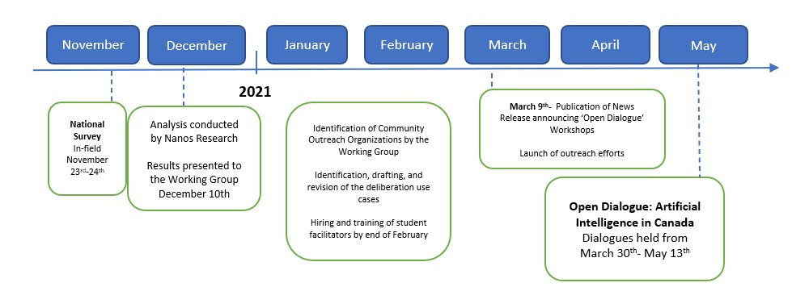

Figure 2. Timeline of fieldwork for the research conducted by the Public Awareness Working Group

Figure 2 - Text version

In fulfillment of this work, the Public Awareness Working Group met throughout the summer 2020 and initially developed a draft proposal for an online survey. The survey questions followed three themes: assessing AI literacy amongst the Canadian public; identifying areas of AI hope or optimism; and identifying areas of AI fear or concern. The first theme of AI literacy was proposed with the objective to understand familiarity with AI in Canada, including its uses and impacts. The intent of the latter two themes was to determine topics for the workshops to focus on, with the rationale that the most significant value will be derived from workshops that centre around use cases of AI adoption that are not already areas of widespread consensus, or of little perceived impact.

Following the development of the initial draft, Nanos Research was retained by Innovation, Science and Economic Development Canada (ISED) to execute the survey. In November 2020, Nanos launched a national, bilingual online survey to over 1,200 adult Canadians drawn from a non-probability panel.

Informed by the results from the national survey, the Working Group, in partnership with CIFAR and Algora Lab (University of Montréal), launched a series of workshops titled [Open Dialogue: Artificial Intelligence in Canada](https://events.cifar.ca/website/21689/fca/home/). The Open Dialogue sessions invited Canadians to share their views on the perceptions, opportunities, and challenges of AI development through a series of pan-Canadian virtual workshops held through March to May of 2021. Taking an approach informed by the[Montréal Declaration for a Responsible Development of Artificial Intelligence](https://www.montrealdeclaration-responsibleai.com/) and the[Open Dialogue on AI Ethics](https://opendialogueonai.com/), the workshops included facilitated discussions, by trained university students who served as notetakers and facilitators, based on specific AI use case scenarios. Participants were invited to consider and discuss the ethical dilemmas posed by hypothetical AI applications. Over the course of the virtual workshops, the Working Group engaged with 437 Canadians across the country in virtual sessions where participants were invited to consider and discuss the ethical dilemmas posed by AI applications through exploring specific AI use case scenarios. As a part of this engagement, the Working Group also hosted dedicated youth workshops, which engaged 149 secondary school students, who shared their views and guidance on ethical AI development.

**3. Research findings**

The research was designed with the goal of providing recommendations for comprehensive and meaningful engagement strategies that would enable the Government of Canada to further engage with the Canadian public on the responsible and ethical development of AI. Public awareness in this context is not limited to AI literacy development exercises, but also constitutes improving the relationship between government and citizens around AI, with an aim to engage citizens to provide meaningful contributions to the development and governance of AI systems. To this end, the Working Group's research explored three key areas of interest. First, it was essential to **establish a baseline of the level of AI literacy** amongst people in Canada in order to contextualize their perceptions of the technology and the outlook on the potential applications. Second, as comprehension of the technology is only one facet of understanding how the Canadian public thinks and feels about AI, the Working Group sought to **understand the perceptions of the technology and its potential impact** on various parts of life in Canada. Finally, in informing a long-term AI engagement strategy that reflects the needs of the public, the research sought to **gauge the current appetite amongst people in Canada to engage more** on understanding this technology, and the specific AI topics or themes that resonate with Canadians and provide the most significant opportunities for further engagement.

The following findings provide an analysis of the collective results gathered from both the national survey and public deliberations research conducted by the Working Group, but by no means reflect the totality of the rich and diverse insights that were collected, which span topics beyond literacy and awareness to include issues of regulation, skills and talent development, as well as the identification of the key ethical dilemmas posed by this emerging technology. In acknowledgement of the value of these contributions that fall beyond the scope of the Working Group's mandate, readers are encouraged to additionally engage with the full reports of each research project's findings via web links provided here:

[**Views of Canadians on Artificial Intelligence (2020)**](https://epe.lac-bac.gc.ca/100/200/301/pwgsc-tpsgc/por-ef/innovation_science_economic_development_canada/2021/050-20-e/index.html)

**Open Dialogue: Artificial Intelligence in Canada (2021)**

While a detailed discussion of the barriers and limitations faced during the research conducted in community engagement will be expanded upon below, it is important to acknowledge the challenges faced in collecting insights from a population that reflects those who reside in Canada. Though it is true that the COVID-19 pandemic resulted in its own unique set of barriers, such as the inability to gather in person, the pandemic also brought into a striking relief the pre-existing barriers to engagement and the fragility of access to programs, initiatives, and services that exists for many communities across Canada. For these reasons, we will refer to the sample populations as "respondents" and "participants" respectively when discussing the insights derived from the National Survey and Open Dialogue consultations, so as not to imply their experiences are universal to all peoples in Canada. Although these findings were collected and developed in a limited context, they provide a basis for future engagement and dialogue that benefit from the lessons learned during this research.

**Chapter outline**

* 3.1 [**AI literacy**](https://ised-isde.canada.ca/site/advisory-council-artificial-intelligence/en/public-awareness-working-group/learning-together-responsible-artificial-intelligence#6.1)
  + 3.1.1 [Profile of AI literacy in Canada: national survey respondents](https://ised-isde.canada.ca/site/advisory-council-artificial-intelligence/en/public-awareness-working-group/learning-together-responsible-artificial-intelligence#6.1.1)
  + 3.1.2 [Literacy gaps and non-standardized knowledge sources](https://ised-isde.canada.ca/site/advisory-council-artificial-intelligence/en/public-awareness-working-group/learning-together-responsible-artificial-intelligence#6.1.2)
* 3.2 [**Perceptions of AI: Where are the opportunities and sources of optimism? What are the concerns and challenges?**](https://ised-isde.canada.ca/site/advisory-council-artificial-intelligence/en/public-awareness-working-group/learning-together-responsible-artificial-intelligence#6.2)
  + 3.2.1 [General perception of AI](https://ised-isde.canada.ca/site/advisory-council-artificial-intelligence/en/public-awareness-working-group/learning-together-responsible-artificial-intelligence#6.2.1)
  + 3.2.2 [Perception of impact and value of AI by sector](https://ised-isde.canada.ca/site/advisory-council-artificial-intelligence/en/public-awareness-working-group/learning-together-responsible-artificial-intelligence#6.2.2)
  + 3.2.3 ["Human-in-the-loop" and other confidence-building measures](https://ised-isde.canada.ca/site/advisory-council-artificial-intelligence/en/public-awareness-working-group/learning-together-responsible-artificial-intelligence#6.2.3)
* 3.3 [**Looking ahead: How much more do people in Canada want to know about AI?**](https://ised-isde.canada.ca/site/advisory-council-artificial-intelligence/en/public-awareness-working-group/learning-together-responsible-artificial-intelligence#6.3)
* 3.4 [**Barriers to engagement: Who we did (and did not) hear from**](https://ised-isde.canada.ca/site/advisory-council-artificial-intelligence/en/public-awareness-working-group/learning-together-responsible-artificial-intelligence#6.4)
  + 3.4.1 [Survey demographics](https://ised-isde.canada.ca/site/advisory-council-artificial-intelligence/en/public-awareness-working-group/learning-together-responsible-artificial-intelligence#6.4.1)
  + 3.4.2 [Open Dialogue demographics](https://ised-isde.canada.ca/site/advisory-council-artificial-intelligence/en/public-awareness-working-group/learning-together-responsible-artificial-intelligence#6.4.2)
  + 3.4.3 [Barriers to engagement faced in our consultation](https://ised-isde.canada.ca/site/advisory-council-artificial-intelligence/en/public-awareness-working-group/learning-together-responsible-artificial-intelligence#6.4.3)
  + 3.4.4 [A word on local approaches to AI awareness initiatives](https://ised-isde.canada.ca/site/advisory-council-artificial-intelligence/en/public-awareness-working-group/learning-together-responsible-artificial-intelligence#6.4.4)

**3.1 AI literacy**

**3.1.1 Profile of AI literacy in Canada: national survey respondents**

In assessing the population's technical knowledge, it was critical to the Working Group that the survey questions were designed with appropriate language to avoid the conflation of technical knowledge with a normative assessment of the validity of respondents' perceptions of the technology's future impacts. Reflecting this objective, the survey involved both an initial self-assessment of respondents' familiarity with AI before providing a simple, plain-language definition of AI for the respondents to reference when completing knowledge-based questions to determine demonstrated familiarity with the technology.

In terms of self-reported AI Literacy, nearly three-quarters of respondents identified themselves as familiar to somewhat familiar with AI. When asked to rate their familiarity with AI on a scale of familiar to not familiar, self-reported familiarity was highest amongst men (79.6%), younger individuals aged 18-34 (80.4%), and residents of Ontario (81.2%). Amongst assessed demographics, respondents from Quebec reported the lowest familiarity, with 55.3% identifying themselves as familiar or somewhat familiar with AI.

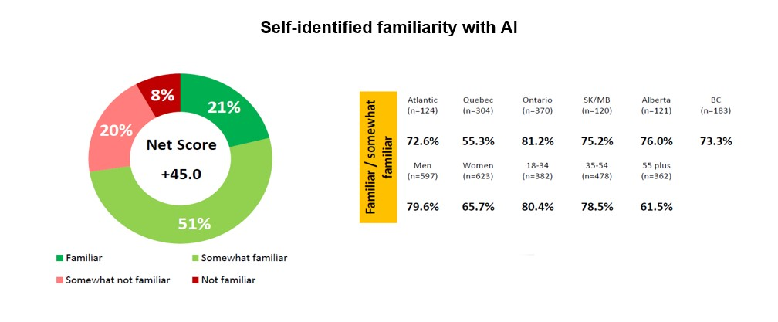

Figure 3. Respondent identification of their level of familiarity with AI prior to the survey (Q. Are you familiar, somewhat familiar, somewhat not familiar or not familiar with AI?)

Figure 3 – Text version

With approximately 71% of respondents self-reporting some level of familiarity with AI, this result stands in stark contrast to the results collected by Deloitte in their 2019 report, "Canada's AI imperative – Overcoming risks, building trust" where only 4 percent of Canadians felt confident about explaining what AI is and how it works.[Footnote8](https://ised-isde.canada.ca/site/advisory-council-artificial-intelligence/en/public-awareness-working-group/learning-together-responsible-artificial-intelligence#fn8) However, this discrepancy may reflect the gap in knowledge about AI from a technical perspective rather than a general, contextual understanding of AI informed through respondent engagements within their daily lives. Simply, while the general public may not feel confident explaining *how* Artificial Intelligence Systems (AIS) make decisions, they are increasingly aware of the ways in which AIS are being used are being reported upon in the media.

Promisingly, the self-assessed familiarity reflects a growing knowledge of AI and its capabilities. On average, when answering questions designed to explore the accuracy of respondent's knowledge around the current state of AI technologies, respondents were successful at correctly identifying whether AI can perform a task for 7 of 11 tested capabilities, such as:

* Learn from data to increase understanding
* Perform video surveillance
* Interpret speech
* Play games
* Interpret images
* Replace humans doing dangerous tasks
* Help solve business problems
* Think logically
* Compose music
* Behave as humans do in social settings
* Feel emotion

Furthermore, respondents were also able to correctly distinguish whether a technology uses AI an average of 4.2 out of 6 times amongst the list of common AI-enabled technologies such as virtual assistants, predictive search terms, recommender systems, and email spam filters.

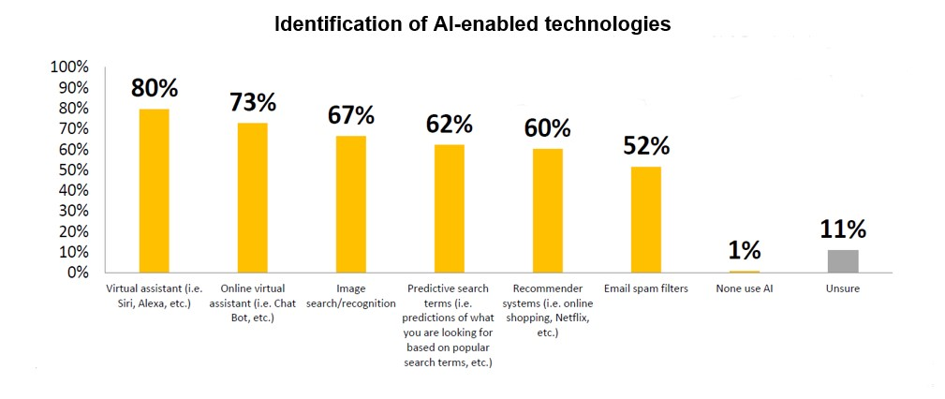

Figure 4. Respondent identification of whether listed technologies use AI (Q. Which of the following technologies use AI? (Check all that apply)

Figure 4 – Text version

In diving deeper into respondents' understanding of what AI can and cannot do at this time, respondents were tasked to examine a series of problem-types and indicate whether they believed the problem is one where AI does a very good, good, average, poor, or very poor job. Respondents again performed well on this assessment, with most (66.2%) correctly rating the ability of AI to recognize the differences between images as very good or good, while rating AI's ability to make ethical decisions in a particular context the lowest (39.3% scoring this competency as poor or very poor). However, many respondents responded less accurately on whether or not AI could identify the influence of human bias. Only 25% of respondents correctly identified AI's capability of identifying human bias as very poor or poor, with 28% of responses selecting the AI's ability to do so as being very good or good. This may stem from a lack of clarity surrounding the use and definition of the term bias, the source of the bias, and/or the task the respondent is assuming the AI is completing. For example, popular reporting has identified AI as a solution to mitigating bias in job candidate assessments, which may create a misconception or confusion around AI mitigating bias instead of identifying it.

Overall, respondents demonstrated the least confidence in assessing the role and operationalization of ethics as it relates to the use and development of AI technologies. When provided with the prompt, "people who develop AI do so in an ethical manner", though 48% of respondents agreed or strongly agreed with this statement, 29% identified that they were unsure. This gap in confidence with assessing questions of ethics is further reinforced when comparing the results to the prompt, "Computers can be programmed to make ethical decisions". When asked to assess their level of agreement with a series of statements on the capabilities of AI, 42% of respondents agreed, with 38% responding negatively and 19% unsure.

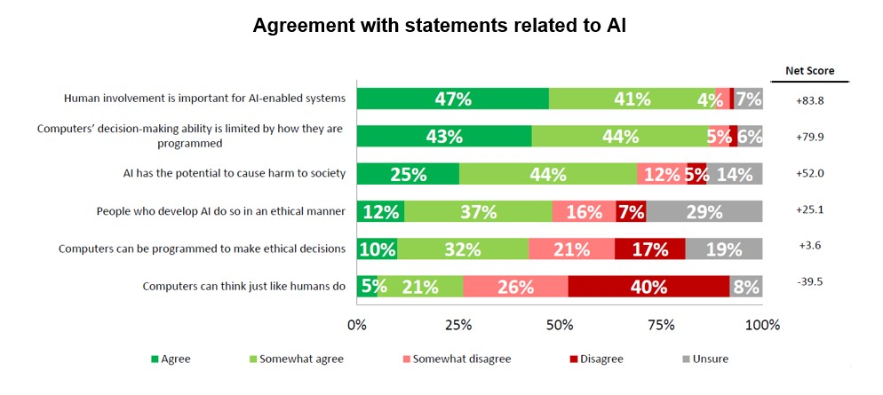

Figure 5. Respondents identified level of agreement with various statement assessing AI's capabilities or design (Q. Do you agree, somewhat agree, somewhat disagree or disagree with each of the following?)

Figure 5 – Text version

Of the six prompts assessing the veracity of statements about AI's capabilities, the two examples referring to ethics produced the highest proportion of "unsure" responses, as well as the most moderate splits between proportion of respondents rating the statements positively versus negatively. This may reflect a gap in the popular literacy around ethics and how to define/assess ethics as it pertains to AI development and applications.

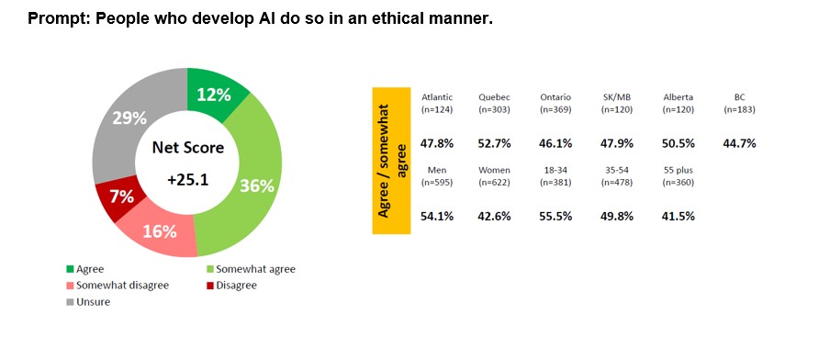

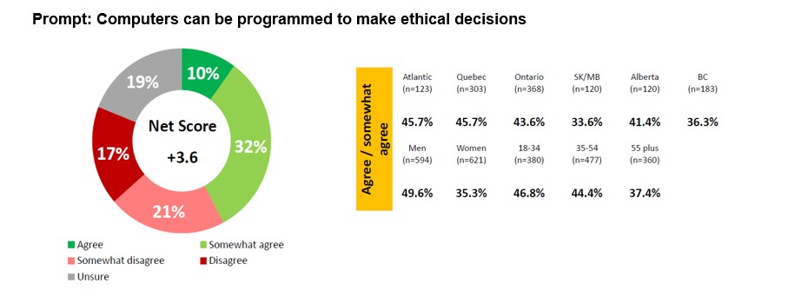

Figure 6. comparative breakdown across assessed demographics of agreement with the prompting statements "people who develop AI do so in an ethical manner" and "computers can be programmed to make ethical decisions".

Figure 6 – Text version

Yet, when comparing consolidated response averages—and average responses across the demographic breakdowns by age, region and gender—respondents on average placed greater confidence in the human developers of AI to act ethically than they did in the ability for computers to make ethical decisions. This gap was most pronounced amongst residents of Saskatchewan and Manitoba, women, and those aged 18-34 years. We will see this greater confidence being correlated with an increased role for human involvement and oversight discussed in section 3.2 when evaluating the perceptions of AIS.

**3.1.2 Literacy gaps and non-standardized knowledge sources**

With over two-thirds of respondents recording themselves as familiar with AI, the natural question becomes—where did they learn about it? As part of the effort to understand the degree of knowledge people in Canada already have around AI, it is equally as important to know their sources of information in order to identify opportunities for future literacy and education. For those who reported that they were familiar or somewhat familiar with AI, they were asked to provide open-ended feedback to identify where they received their initial exposure to learning about AI. Reflecting a more informal array of sources, respondents most frequently say they heard of AI through the news (20.7%), internet (19.5%), and television/documentary programming (13.3%), with only 4.9% and 4.6% of respondents reporting having heard of AI through school or work respectively.

This result raises two critical implications: first, a striking deficit in exposure to AI in more traditional education/training sources; and second, the potential susceptibility of the public to misinformation due to the lack of formal and standardized distribution of accurate information on AI systems (AIS) and their applications. Given the prevalence of AIS in many aspects of everyday life, a new type of digital divide is emerging, characterized by those who know how to use and take advantage of AIS, and those who do not. The development of AI literacy is increasingly going to be determined by equity of access and participation within both professional and public life in Canada.[Footnote9](https://ised-isde.canada.ca/site/advisory-council-artificial-intelligence/en/public-awareness-working-group/learning-together-responsible-artificial-intelligence#fn9) Furthermore, as non-traditional media sources— namely social media platforms, with over half of Canadian's surveyed in the 2021 Reuters Institute Digital News Report reporting getting their news from social media[Footnote10](https://ised-isde.canada.ca/site/advisory-council-artificial-intelligence/en/public-awareness-working-group/learning-together-responsible-artificial-intelligence#fn10) — grow their influence on public discourse, there are increasing concerns about the level of misuse and propagation of disinformation. Put simply—while current survey data indicates that these non-traditional media have not produced a significant degree of inaccurate understandings of AI and its abilities — the importance of AI literacy to the ability of individuals to participate equally in the economy and society of the future requires a more purposeful and systematic effort to ensure that the Canadian public is receiving accurate information. Providing people in Canada with trusted and reliable resources of information on AIS will assist in continuing to move Canada's AI literacy rates along a positive trajectory.

The concern over a gap in organized AI literacy education was reflected amongst participants in the Open Dialogue: Artificial Intelligence in Canada workshops. Across the 19 national workshops, participants consistently felt that overall, the public lacks sufficient knowledge and accurate information about AI technologies—a lack of knowledge which ultimately leads to increased social risks of the technologies as the public is limited in their ability to effectively use, engage with, and critically evaluate AIS. Interestingly, when asked to further define what they perceive to be an adequate awareness of AI, participants described two dimensions: basic knowledge of AI technology, and awareness of how to engage in critical, ethical, and political elements of AI. Participants emphasized that "AI awareness" must include providing the public with a better understanding of how AI systems function, as well as additional context of AI institutional deployment or commercialization. Many shared that a better understanding of AI is a necessary and empowering condition that enables citizens to engage in informed discussion and decision-making about the responsible use and development of AI, reaffirming the link between knowledge and autonomy, as well as information and consent. Recalling the gap in comfort with assessing questions of ethics observed amongst survey respondents, the issue of insufficient education on the social, political, and ethical considerations of AI is as critical of a barrier to the potential user of AIS as a lack of technical understanding.

Participants recognized that learning about AI must begin early. There was a broadly shared opinion that people in Canada should be educated from an early age about how these AI systems can work, so that the next generation of citizens can make informed decisions. The degree to which participants and survey respondents emphasized the value of engaging with AI literacy at all ages will be explored in greater detail in section 3.3, which will provide an overview of the appetite amongst the Canadian public for more AI literacy learning opportunities.

**3.1 Key takeaways**

* Nearly three-quarters of survey respondents reported some familiarity with AI, particularly men, individuals aged 18-34, and residents of Ontario. Respondents were, on average, capable of correctly assessing 7 out of 11 capabilities of AI, and were able to distinguish whether a technology uses AI 4.2 out of 6 times.
* A high percentage of survey respondents felt unsure about the ethics of AI, with 29% unsure whether "people who develop AI do so in an ethical manner" and 19% unsure if "computers can be programmed to make ethical decisions."
* Respondents familiar with AI were more likely to have heard of AI through non-traditional sources, such as the internet or television, than through school or work.
* Workshop participants emphasized that AI literacy must include both technical knowledge and an awareness of how to engage in critical, ethical, and political elements of AI.

**3.2 Perceptions of AI: Where are the opportunities and sources of optimism? What are the concerns and challenges?**

Despite high self-reporting of AI literacy levels amongst those surveyed, the rapid pace of AI technology growth and sophistication, along with the pervasiveness of media stories on large companies and governments misusing AI technology, risk contributing to a public perception that AI is inherently harmful or concerning. Likewise, the proliferation of articles and news features promising that AI will "change the world" and offering tech-based solutions to seemingly all of modern society's most intractable problems — such as climate change — risks creating "techno-optimism", or the belief that the progress of technological development can and will be used for the betterment of humankind. Such techno-optimism could similarly sway public opinion towards less critical evaluations of these tools. To take full advantage of AI's potential benefits, understanding the current perceptions of AI amongst the people in Canada is key to building stable and qualified public trust in the governance and responsible use and development of AIS. The following section presents the survey respondents' perceptions of AI and how it will impact their daily lives overall and across multiple sectors, conditions upon which the adoption of AI technologies would be considered more trustworthy, and recommendations made by participants of the Open Dialogues to moderate the pull towards techno-optimism or techno-pessimism.

**3.2.1 General perception of AI**

Reporting on how they perceive the impact of AI overall, respondents to the national survey were nearly seven times more likely to say they believed the impact of AI on Canada will be very positive rather than very negative, and four times more likely to say that the impact on themselves will be very positive rather than very negative. Overall, amongst the demographics of age, gender, and geography, respondents who were residents of Saskatchewan and Manitoba, women, and older Canadians gave marginally lower positivity ratings to the impact of AI on them personally. Of these groups, only residents of Saskatchewan and Manitoba are less likely to rate the impact of AI on Canada as positive. Overall, however, these deviations between the lower scoring demographics and the mean rating were by a point or less a 10-point scale, resulting in an optimistic recorded outlook when considering the net impact of AI.

Yet this optimism around the potential of AIS is not isolated to the more generalized line of inquiry presented in the survey's framing. In a post-deliberation survey conducted following the Open Dialogue public workshops, 74% of participants recorded that they thought the social benefits of AI were significant, while only 8% disagreed. Similarly, when asked whether they believed the development of AI was generally worrying, 49% of participants disagreed, while 24% and 26% agreed or had no opinion respectively.

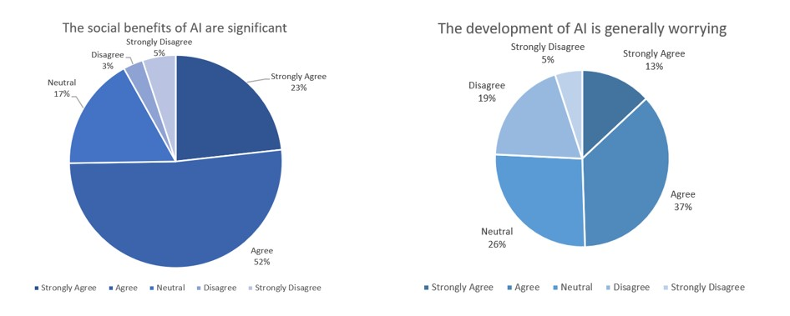

Figure 7. Distributions of the post-deliberation survey (Q1 + Q2) results for the general public workshops of the 'Open Dialogue: Artificial Intelligence in Canada' workshop series.

Figure 7 – Text version

However, demonstrating how tenuous this current positive perception may be, only 42% of participants identified themselves as believing the social benefits of AI outweigh the negative effects, with 17% holding the opposite view and 41% having no opinion. This proportion of overall participants who did not have a strong opinion one way or another presents a population that is potentially more susceptible to breaking towards a more positive or negative view in the wake of a public scandal or otherwise major incident involving AI. One important caveat to these findings, however, is that the pre- and post-deliberation survey results were collected from all participants as a single aggregate sample, rather than separating them by the use case that they deliberated. As such, depending on the nature of the AIS presented in the deliberation, participants may have assessed the questions more critically or positively based on their particular use case rather than responding to their assessment of AI in general. Several participants also raised issues with the question's validity as they felt that their answers were dependent on whether or not certain regulations or other governance measures were implemented, would have been different depending on the type of AIS they were assessing, and preemptively assumed that all participants felt that AI should be adopted at all.

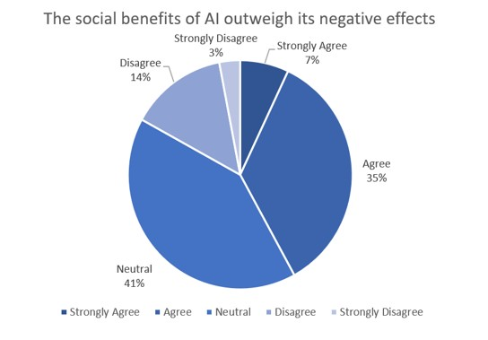

Figure 8. Distributions of the post-deliberation survey results (Q4) for the general public workshops of the 'Open Dialogue: Artificial Intelligence in Canada' workshop series.

Figure 8 – Text version

**3.2.1 Key takeaways**

* Survey respondents were generally optimistic about the impact of AI on Canada and themselves. 74% of workshop participants reported a belief that the social benefits of AI are significant.
* Framing of AI in different contexts may impact the public's perception of AI, as only 42% of workshop participants reported beliefs that the social benefits of AI will outweigh the negative effects.

**3.2.2 Perception of impact and value of AI by sector**

Across the national survey and Open Dialogue workshops, as discussions transitioned from abstract assessment towards more personal or familiar assessments of AIS usage, respondents became more moderate in their optimism on AI impacts. This moderation is largely unsurprising as it is easier to reflect upon and critically evaluate subjects that are smaller, more familiar, or more clearly defined. In fact, this is in part the rationale behind the use of prospective AI use-case scenarios in the Open Dialogue deliberations, to allow the participants a foundation upon which to build their assessment of the ethical dilemmas posed by particular applications.

When narrowing the focus of respondents' assessments on the perceived sector-specific impacts of AI, there were nuances in the perception of AI technologies based on the economic sector or realm within the respondent's life in which the AIS would operate. Specifically, respondents most frequently predicted that they see AI having a positive net impact within the manufacturing, transportation and banking sectors, with the lowest positive impact scores being recorded for the arts and culture and law enforcement sectors.

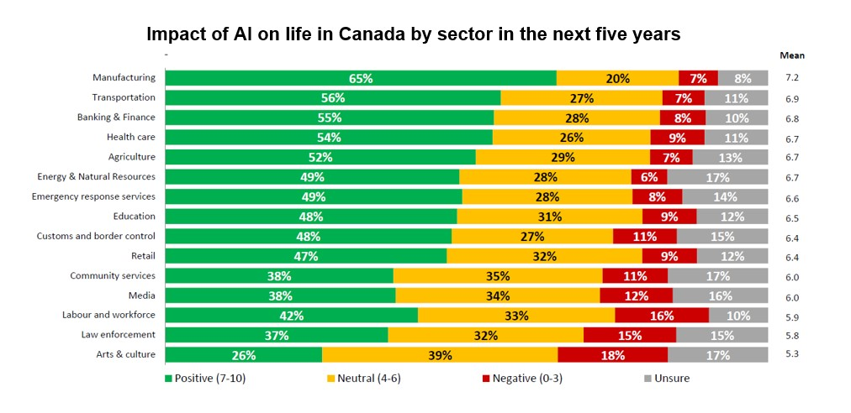

Figure 9. Distribution of respondents scoring of their perceived impact that AI will have in various sectors of the Canadian economy (Q. On a scale from 0, very negative to 10, very positive, how would you rate the impact of AI on the following in the next five years?).

Figure 9 – Text version

When asked to evaluate the same sectors based on how concerned the respondent is about the negative impacts of AI in this space, respondents most frequently expressed concern about the impact of AI on law enforcement and the labour force sectors, with most frequently saying they are not concerned about the impact of AI on arts and culture, agriculture and manufacturing sectors.

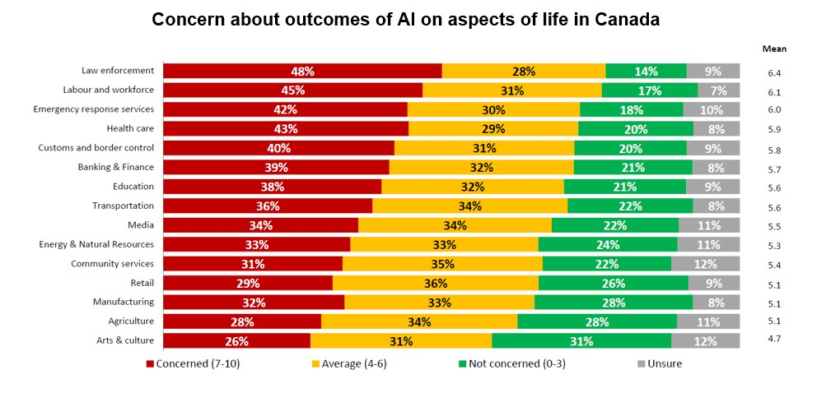

Figure 10. Distribution of respondents scoring of their level of concern about the impact that AI will have in various sectors of the Canadian economy (Q. On a scale from 0, not at all concerned to 10, very concerned, how would you rate your concern about the possible negative outcomes from the use of AI in the following aspects of life in Canada?).

Figure 10 – Text version

When asked about their optimism around future AI applications or uses, survey respondents most frequently said they are hopeful that AI will make life easier by improving productivity and reducing errors, followed by generating improvements in the medical field and health. To a similar open-ended prompt regarding areas of concern, respondents identified that they are most concerned about job loss and AI replacing humans, followed by privacy, security, and hacking, and losing control of the AI or malfunction of the AIS. Reflecting these concerns, the survey respondents also most frequently identified governments and academic institutions as the actors who should take the lead on developing AI solutions, with over half ranking these two institutions as their first choice.

Although the survey did not parse in greater detail the rationale behind respondents' selection of government and academic institutions as their AI provider of preference, the results of the Open Dialogue workshops indicate that this finding is motivated significantly by the perceived severity of the risks posed by certain AIS. Depending on the nature of the risks considered, and the intensity and permanency of the potential harm, Open Dialogue participants reflected a desire for the Government of Canada to adopt a form of precautionary principle in the case of high-risk AIS that pose serious risk of physical and psychological damage, or cause harm to individuals and groups through deprivation of certain fundamental rights.

**The Precautionary Principle**

Formulations of the precautionary principle can be divided into two major groups: **argumentative** and **prescriptive** versions of the principle.

An argumentative version of the precautionary principle is centred around what kinds of arguments are admissible in decision-making. They do not describe what actions should be taken, but rather define what arguments are acceptable to evoke an action (or inaction). (Sandin, Peterson, and others 2002)

Prescriptive versions of the precautionary principle prescribe actions with most prescriptive versions of the precautionary principle sharing four common components [Sandin, 1999]. Consider the following possible formulation of the precautionary principle: It is mandatory to limit, regulate, or prevent potentially dangerous technologies even before scientific proof is established.

We find four different components in this formulation, namely:

1. the **threat component**, expressed in the phrase "potentially dangerous technologies";
2. the **uncertainty component**, expressed in the phrase "even before scientific proof is established";
3. the **action component**, expressed in the phrase "to limit, regulate, or prevent";
4. the **prescription component**, expressed in the phrase "is mandatory".

The first two of these can be summarized as the trigger of the precautionary principle, whereas the last two constitute the precautionary response [Ahteensuu, 2008]. The uncertainty dimension ensures that action is triggered even in the absence of full scientific evidence. It is the most characteristic part of the principle. It is what distinguishes the precautionary principle from other principles or argumentation forms for protection.

Sven Ove Hansson, [Philosophy of Technology and Engineering Sciences](https://www.sciencedirect.com/book/9780444516671/philosophy-of-technology-and-engineering-sciences), 2009

Mirroring the concerns registered in the national survey, **law enforcement applications were the most significant concern to participants** who—across the nine discussion sessions that addressed this theme—unanimously called for strict control of AIS for mass surveillance and prediction of criminal behaviour, reinforced the necessity that decisions in this sector be made by humans, and in some cases went as far as to suggest their complete ban.

Beyond the unanimity of the suggested response to a particular application (i.e. use of AI for mass surveillance and predictive justice), common ethical concerns were observed across all use-case themes—healthcare, education, predictive justice, administrative services, etc.—that demonstrate the types of concerns that are front of mind for people in Canada when it comes to AI. Perhaps unsurprisingly given the nature of the technology and its potential applications, Open Dialogue participants identified **bias and discrimination**—including concerns raised around inclusion/exclusion and preserving diversity—as key ethical issues in use cases that spanned all sectors included in the workshops. Similarly, **privacy**, **data protection**, **transparency and explainability** were elevated as a key concern in nearly all use case themes. One important caveat to note however is that these findings are limited to what participants identified as their top three ethical issues in their deliberations, consequently, these themes may have been discussed as universally as bias and discrimination but were de-prioritized relative to other concerns in one way or another.

**Insights from the youth deliberations: Bias and discrimination in healthcare**

While deliberating on the Portable Medical Laboratory use case, one of the youth workshop participants highlighted that inequality of access to the technology would lead to discrimination on a geographical basis, specifically a global North and South division. They also mentioned other types of discrimination such as favoring people with implanted microchips, a point that was also highlighted by participants in general public sessions. One participant said:

**"The public discourse can be 'why are you not doing this for the benefit of all of us?' What does it say about you if you opt out of the program, or cannot access it? Does this further marginalize people?"**

Young participants also worried about discrimination on the basis of what would be found in the health data, such as cannabis consumption in blood tests, which bridged into related concerns regarding user data privacy and security.

Naturally, the deliberation on topics within certain use cases identified unique ethical issues, such as animal welfare in the groups discussing the use of AI in slaughterhouse optimization or the importance of human creativity that emerged from deliberations on the "Human Art and Robot Artist" use case. While the ubiquity of certain ethical issues create a clear message of the importance of adequately addressing these concerns through future regulation or other protective measures, the identification of application-specific concerns emphasizes the value of encouraging public consultation and deliberation as a standard practice across all sectors.

**3.2.3 "Human-in-the-loop" and other confidence-building measures**

The intensity of the rejection of certain AI applications, however, does not mean that participants in the Open Dialogue did not also perceive or envision the potential benefits it can bring to Canada. The results of the post-deliberation survey, which was provided to Open Dialogue participants following the completion of their deliberation sessions, demonstrated a qualified optimism in the technology, or rather the institutions and organizations that govern, develop, and deploy AI, on the condition that they are properly regulated. Although the notion of regulation is undefined, 71% of participants believe that AI can be trusted if it is regulated by public authorities to an extent appropriate for the risk-level of the application.

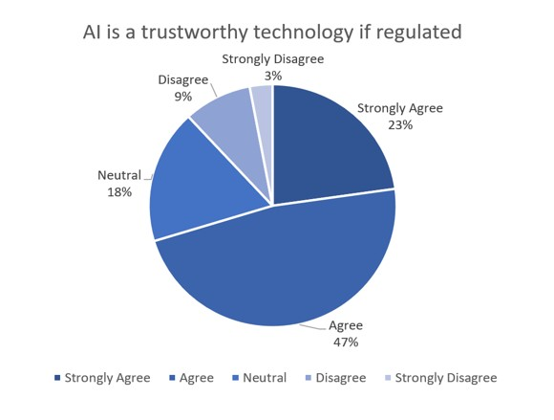

Figure 11. Distributions of the post-deliberation survey results (Q6) for the general public workshops of the 'Open Dialogue: Artificial Intelligence in Canada' workshop series.

Figure 11 – Text version

Even when examining the results of the national survey respondents, despite the optimism over the predicted overall impact of AI in Canada, **nearly two-thirds of respondents believe that AI has the potential to cause harm to society**. Although the survey did not inquire as to the respondents' opinions on how they would like to see this perceived risk mitigated, when asked to reflect on the question of where humans should play a role in the development and deployment of AI, **a strong majority of Canadians say human involvement is required in a variety of aspects related to AI development.** With approximately nine in ten Canadians thinking that humans have a role in all steps of AI development, the results hold consistent across all assessed demographics when asked to select between options of human involvement being required, not required, or an unsure response.

This qualified form of trust—based on the requirement of a human being involved at all stages of the AI's development—additionally served as one of the motivations behind the Open Dialogue participants questioning of the usefulness or relevance of developing AIS in certain contexts where the public expects human intervention and interaction in the case of an undesired outcome. Participants warned specifically against a perceived trend towards techno-solutionism in AI: that is, the tendency to seek technical AI solutions to complex social and political problems. For example, participants were sceptical about the relevance of AI systems in the context of justice and law enforcement. Beyond concerns over the accuracy of AI systems, participants feared an overvaluation of AI systems capacities and decisions. On one hand, given the rapid adoption of AI amongst law enforcement agencies, participants felt there was a rush to use this technology in all areas without proper consideration. On the other hand, they considered that when an AI system is deployed, people will tend to follow the recommendation of the system rather than their own judgment, even if they disagree. Speaking specifically to this point, one participant remarked that, "it would be unethical for this tool to be used to make important decisions on people's lives if the decision process and reasoning behind the outcome is not clear and understandable by the [body governing the algorithm]." Finally, driving directly to the question of the appropriateness of an AIS in this context, participants noted that the AIS in the use case did not address the root cause of the problem of criminality, with some participants proposing that an AIS focused on optimizing crisis response teams, psychological and therapeutic help, or prevention and harm reduction practices should be prioritized instead of enhancing policing techniques.

**"Beyond concerns over the accuracy of AI systems, participants feared an overvaluation of AI systems capacities and decisions."**

The suggestion that came out of these discussions was that developers should consider the relevance of developing an AIS to help solve a socio-economic problem, and that the institutions deploying these solutions should themselves think about whether to fund them and prioritize these technical solutions. Participants often suggested that developers and engineers receive ethics training so that ethics are considered at the design stage of the AIS, not just at the time of deployment, and that more conscious consideration of the needs of the community should be integrated throughout the design and development process. This desire for greater engagement with the developers of AIS presents an opportunity for knowledge exchange between technical experts and the general public, serving both to increase public confidence in the AIS and provide technical teams with a more robust understanding of the user needs and requirements—ultimately resulting in more successful projects.

**Analogies in software development: Requirements gathering processes**

Participants' recommendations that developers should engage holistically with communities when developing AIS aligns with an existing practice in software engineering known as "requirements gathering" or "requirements analysis." In effect, requirements gathering is the process of generating a list of requirements for a software project that will be used as the basis for the formal definition of what the project is. These may include capabilities of the software, and operational considerations like security, error management, and legal compliance. Requirements are solicited from various stakeholders of a system (such as customers, users, vendors, and IT staff), and the process of gathering them is a fundamental component of good software development, as it sets clear targets for developers to aim for. These requirements are frequently revised and modified throughout the project's lifecycle.

Standard techniques and practices used in requirements gathering have a clear relationship to the type of expert-public exchanges described by the Open Dialogue participants. For example, as a part of the process, developers may create a use case diagram, including all the imagined steps in a new process. These use cases are supported by dialogue with stakeholders through interviews, surveys, user observation, focus groups, and workshops.

It is clear that facilitation capabilities for dialogue with the public should already exist in software development ecosystems. These processes could be easily adapted to create a more long-lasting, holistic connection to communities by expanding the definition of who the stakeholders in AI systems may be and how often their feedback is collected

Wiegers, K and J. Beatty, *Software Requirements*, 3rd ed.  (2013)

**3.2.3 Key takeaways**

* 71% of workshop participants agree that AI can be trusted if it is regulated by public authorities appropriate to its risk level. Nine in ten survey respondents believed that humans have a role in all stages of AI development.
* Workshop participants cautioned against applying AI without considering if it is the best tool for the job in complex social and political problems (techno-solutionism), and frequently suggested that engineers and developers of AI receive ethics training.

**3.3 Looking ahead: How much more do people in Canada want to know about AI?**

When considering the growing prominence and importance of AI in the public discourse, when prompted, respondents to the national survey overwhelmingly identified an interest in learning more about AI. **Nearly three-quarters of respondents stated that they were at least somewhat interested in learning more about the subject, with men and residents of Ontario reporting the highest interest.** This disparity, albeit slight, in demographic interest in pursuing opportunities to learn about AI is supported by past research identifying the role gender plays in shaping perceptions. Research has shown that "men are much more likely than women to tinker with and program in-home AI devices and that, compared with women, men perceive their tinkering to be more successful",[Footnote11](https://ised-isde.canada.ca/site/advisory-council-artificial-intelligence/en/public-awareness-working-group/learning-together-responsible-artificial-intelligence#fn11) suggesting the importance of considering learner interests and identity when designing awareness and outreach programs.

When asked to specify where opportunities for greater AI educational programming should be implemented, and what forms this learning should take, Open Dialogue participants suggested that the foundations of AI should be taught in primary school, with an introduction to building the skills required to be able to identify the social and ethical issues of AI introduced in later grade levels. With regards to AI education, respondents noted that a fundamental understanding of how the technology works often underpins understanding of the potential impacts of the different AI applications—which is the knowledge that is critical to being able to evaluate how this technology connects with a variety of social and policy issues.

However, participants were adamant that AI education should not be limited to schools, whether primary, secondary, or post-secondary and beyond. Participants were unanimous in emphasizing that educating about responsible AI is not only a school or workplace issue, but a community issue more broadly, particularly for populations far from urban areas and from disadvantaged or marginalized populations in cities. Therefore, for Open Dialogue participants to consider an AI literacy and public awareness campaign a success, it must support the inclusion of all components of the population living in Canada. This proposal for a Canada-wide inclusive awareness campaign was consistently made in the workshops and variously incorporated a range of potential actions, including:

1. Information available on social networks and other more traditional media, similar to campaigns regarding environmental protection or public health awareness;
2. The development and availability of an online course on the technical and operational foundations of AI, as well as the ethical, social, and economic challenges of its deployment; and
3. A more consistent availability of deliberative consultations as a way to raise awareness and educate about AI.

**Elements of AI, a model for Canada?**

The goal of the Elements of AI course, developed by the University of Helsinki and the company Reaktor, was initially to demystify AI by teaching at least 1% of the European population the basics of AI. The course is available online free of charge, and while it was only available in English in its launch phase, it is now available in several languages, including French. Elements of AI comprises six chapters covering different dimensions of AI-focused digital literacy, including what AI is, how it solves problems, how it can be applied, and the societal challenges of its deployment. Online courses are a popular and accessible delivery model for learning materials, and Elements of AI has reached people from over 170 countries, with over 700,000 students signed up to date.

There are three barriers to dissemination that should be kept in mind when considering its portability to the Canadian context:

1. Even when simplified, the course material remains quite complex for most people. Participants in the Open Dialogue repeatedly emphasized the need for AI awareness and education to be accessible in plain language.
2. The course is time-consuming, estimated to take approximately 50 hours to complete. This is a deterrent for working people in Canada and those with caregiving responsibilities.
3. Being a digital course, access to the material requires a stable high-speed internet connection. While broadband and cellular access is expanding across the country, residents of many areas still do not have reliable connections, preventing their participation in the course.

These barriers show that even though there are numerous benefits to the public offer of an online course, important challenges remain that could impact the effectiveness of online educational resources on AI.

Reaktor and University of Helsinki, [*Elements of AI*](https://www.elementsofai.com/).

A surprising number of the suggestions made during the Open Dialogue refer to consultation with stakeholders and the public, as both an appropriate method of governance, and method for promoting a deeper understanding of the responsible development and ethical use of AI. This enthusiastic support for deliberative consultation is rooted in the democratic ideal of participation in the policy-making process. People in Canada demonstrate a strong desire to be consulted prior to the elaboration of public policies on AI: partly because of a fear of loss of control in the face of increasing automation in administrative processes; and partly because of the principle that those impacted by public policy should have a voice. In line with the goals of the Open Dialogue workshops, these public consultations should aim to include the widest diversity of participants and groups: not just experts or people who already have knowledge, but all people impacted by AI deployment. Reasons for including public consultation centre around its functionality as a method to identify and address well-founded structural concerns, while simultaneously educating participants on alternate perspectives and empowering users through a deeper understanding of the impacts of AIS.

But this conviction to design and host more deliberations faces the barrier many public consultations encounter—particularly those with a science or technology focus. Without prior knowledge, it is difficult to have fruitful exchanges. Without pre-existing knowledge, people feel unqualified and exclude themselves, resulting in significantly higher levels of experts or already interested parties attending the consultations. This self-exclusion, combined with other systemic factors of exclusion, reinforce the phenomenon of marginalization in consultations. To mitigate the self-exclusion of potential participants, the Working Group made available a Guide for Deliberation on AI[Footnote12](https://ised-isde.canada.ca/site/advisory-council-artificial-intelligence/en/public-awareness-working-group/learning-together-responsible-artificial-intelligence#fn12) that provided a common understanding of AI in plain language, including the basic notions of ethics and specifically AI ethics, as well as the rules and objectives of inclusive deliberation. However, as will be discussed in the reflection on who we were able to engage with in our consultations, this was ineffective at driving engagement from those without a university education or pre-existing interest in AI. This indicates that intervention, education, and confidence building measures must occur early in the engagement process and are critical to achieving the diversity of participants desired.

Ensuring all communities across Canada are heard is critical for building trust in the values and principles that guide the development, use, and governance of AI. Representative consultation also ensures actions taken reflect the totality of Canada. This requires purposeful methodologies for identifying and engaging with populations, co-development of deliberative materials, and a conscious reflection of the priorities, concerns, and lived realities of the communities with whom you are consulting. Just as AI solutions are expected, if not demanded, not to be 'one-size-fits-all', neither can efforts to engage with communities on how to improve and better benefit from these systems be designed with only one identity and experience in mind.

**3.3 Key takeaways**

* Nearly three-quarters of survey respondents reported interest in learning more about AI.
* Workshop participants suggested that foundations of AI should be taught in schools, including primary schools, but also unanimously agreed that AI education not be limited to schools. Suggestions included outreach to rural populations, and disadvantaged or marginalized urban populations, and called for public awareness campaigns and more freely available educational resources on AI, such as online courses.
* People in Canada desire deliberate, sustained consultation on the subject of AI, with a special focus on reaching diverse communities across the country.

**3.4 Barriers to engagement: Who we did (and did not) hear from**

The Working Group was provided the mandate by the Government of Canada's Advisory Council on AI to design and engage in a dialogue on AI and identifying methods for sustained and effective public awareness amongst the Canadian public. Originally scheduled to take place in person, the COVID-19 pandemic required most of this work to be carried out online, altering the format of the proposed consultation approach and survey methods, and requiring a careful navigation of the new challenges and realities posed by transitioning to digital-only methods. While encouraged by the number of people in Canada that were engaged, it is also important to reflect on the barriers faced in accessing various communities, and how these barriers affected those able to participate in this research. This section will briefly review the demographics who participated in the national survey and Open Dialogue workshops, before elaborating on some of the barriers faced in recruiting participants for both stages of research. Finally, it will conclude with a note on the value of local initiatives in promoting overall levels of national AI awareness.

**3.4.1 Survey demographics**

Following the development of an initial draft questionnaire by the Working Group, Nanos Research was retained by Innovation, Science and Economic Development (ISED) to co-develop and carry out the final iteration of the survey. Nanos undertook an online survey conducted in both English and French of 1,222 Canadians, 18 years of age or older, between November 23rd to 24th, 2020 drawn from a non-probability panel. This option was scoped at outset to focus in a particular way, given time and breadth and resources and, as a result, targeted population sampling—for ethnocultural and generational diversity, Indigenous peoples, and persons with disabilities—and non-web methods such as telephone survey delivery were beyond the remit of this first research effort.

The sample captured the demographics of gender (limited to male/female/non-binary), age, and geography as validated by respondents' six-digit postal code. The results were statistically checked and weighted by age and gender using the latest Census information, and the sample is geographically stratified to be representative of Canada. In addition to age, gender, and geography, demographic information on education, income and ethnocultural identity was collected, however the responses were not achieved in sufficient numbers to impact the results. Additionally, due to issues of parental consent, along with time/personal resources to design and host more than one survey, the choice was made to limit the survey to those 18 years of age and older.

A full breakdown of the population surveyed can be found in Annex A of this report.

**3.4.2 Open Dialogue demographics**

The Open Dialogue workshops were divided into two 'types' of workshops depending on their intended audience's age: general public and youth workshops. Initial scoping work was undertaken to identify the resources, requirements, and best practices for proceeding with the development and conducting of Indigenous-focused workshops. A critical path for engagement with national governing bodies, Indigenous-led organizations, and other community partners who work actively and closely with Indigenous communities was developed in consultation with the generous input and guidance from community leaders and those who have experience in consultation work. However, the decision was made to prioritize a focus on Indigenous engagement as central to the second phase of research, which is expected to take place in 2023. Due to the varying demographic constraints, consultation formations, and participant recruitment methods, these two 'types' of workshops will be discussed separately.

**3.4.2.a General public workshops**

The Open Dialogue workshops for the general public carried out from March 30th to May 13th in the format of virtual video conferences across Canada in both regionally targeted workshops—to accommodate for time zone differences—and later national workshops that occurred in both English and French. Over the 13 workshops, 288 individuals participated from six different provinces (Ontario, Quebec, British Columbia, Alberta, New Brunswick and Saskatchewan) out of a total of 750 registrations.

Statistics regarding participant demographics were collected from two different sources:

* **Online registration:** When registering for the workshops, participants were required to enter their postal code and city of origin.
* **Online survey:** Participants were invited to complete a voluntary online survey following the deliberations. This data is more detailed (age, gender, and education), but less representative, as only 128 participants (29%) completed the survey

Of the participants who submitted demographic information, 57% identified as female, 39% as male, 2% as queer and 1% as transgender. While, the workshops recorded a high participation rate amongst those aged 18-44, we were able to reach people across all age brackets. It is also important to note that of the adult participants, 91% identified themselves as having achieved at least one university degree, which significantly exceeds the proportion of the actual population in Canada with a higher education. Only one person amongst the participants did not have a degree or college diploma.

Outreach invitations were distributed to a list of over 350 community social organizations across the country compiled by members of the Working Group and with input from teams across ISED engaged in various outreach activities, including ISED regional offices. These invitations encouraged organisations to share the registration information with their members with the goal of recruiting participants who may normally fall outside of the standard engagement stakeholder networks for AI. This direct outreach was supplemented by outreach and advertising on social media platforms (LinkedIn, Facebook, Instagram, and Twitter) by members of the Advisory Council, Working Group, ISED, and CIFAR, alongside a traditional news release by ISED and digital advertising through CIFAR to drive awareness of the consultations. Finally, to drive further participation in the French-language workshops, the International observatory on the societal impacts of AI and digital technology (OBVIA) in Quebec advertised amongst their members and served as hosts for one of the French workshops.

**3.4.2.b Youth workshops**

Unlike the general public workshops, the youth workshops for the Open Dialogue were arranged directly with interested teachers who registered their whole class to participate in lieu of their standard activities. Across 6 workshops—5 French and 1 English—149 secondary school students participated in abbreviated deliberation sessions, adjusted to reflect appropriate use-cases and session duration (workshops were required to fit within a standard class length). The sessions were predominantly conducted in Montréal and involved a significant number of female participants, as three of the workshops being hosted by an all-girls high school. Recruitment for the youth sessions was supported by Working Group members from Let's Talk Science and Kids Code Jeunesse respectively.

**3.4.3 Barriers to engagement faced in our consultation**

In reflecting on the successes and struggles of the engagement activities the Working Group has undertaken in conducting this research, there were several barriers and/or limitations faced by both the Working Group and the public in bridging the gap to achieve the desired inclusion and diversity in our research. While this by no means represents a totality of all the factors that prevent various communities and individuals from participating equally in consultation activities, the following list provides a snapshot of some of the challenges that were encountered, listed in no particular order of importance.

**Accessibility:** The ability to sufficiently adapt the research to accommodate persons with disabilities was affected due to limitations inherent with current digital tools. While the Zoom platform used to host the deliberations did have the capacity for automated closed-captioning, and facilitators were available to read out text on screen to participants with vision issues, both were limited in providing a comparably smooth experience for participants who required these accommodations. Likewise, the survey did not include alternate delivery methods such as telephone responses, which prohibited the participation of those with visual impairments.

**Digital infrastructure:** New data from the Canadian Internet Registration Authority (CIRA) suggests that between the start of the pandemic in March 2020 and March 2021, the median internet download speed in rural areas improved at a much slower rate than in urban centers.[Footnote13](https://ised-isde.canada.ca/site/advisory-council-artificial-intelligence/en/public-awareness-working-group/learning-together-responsible-artificial-intelligence#fn13) All engagement activities required at minimum the capacity to connect to the internet. The video conference format of the Open Dialogue deliberations was only able to be fully experienced without significant disruption or risk of disconnection. Although a teleconference line was available, this prevented participants from participating on an equal footing with the on-camera participants, including prohibiting their ability to complete the pre- and post-deliberation surveys.

**Time commitment:** The Open Dialogue workshops required a three-hour time commitment by participants. For individuals whose participation was not supported by their workplace, a requirement to participate outside of the standard workday, in lieu of paid work hours, or during the weekend increased the opportunity-cost of participation.

**Competing care priorities:** Interplaying with the challenges of competing time commitments, members of the public who provide childcare or other caregiving roles may have been unable to commit to a sufficient period of uninterrupted time to participate in a full workshop, particularly in lockdown restrictions that limited available personal space.

**Languages:** Both the survey and Open Dialogue workshops were conducted in either French or English. This included the provided supplementary education materials provided to workshop participants, such as the Guide to Deliberation. As such, populations such as newcomers, permanent residents, or other persons in Canada who are less confident in participating in technical or extended deliberations or readings in either of Canada's official languages would be more likely to self-exclude from participating.

**Resources:** In the rollout and design of the national survey, the initial focus was on a broad set of useful data. That said, the absence of dedicated resources for accessibility and inclusion of targeted populations limited the methods of distribution and oversampling of populations that may otherwise be insufficiently captured in the results. This meant that off-line communities or those with limited connectivity were unable to participate in the survey work, and that certain types of demographic diversity (i.e., ethnocultural diversity) could only be incidentally captured with no guarantee of sufficient data to engage in a comparative analysis.

**Community partners:** Similar to how the survey lacked alternate methods for contacting off-line populations, the absence of early engagement with community partners (whether contractually or on a voluntary basis) hindered the inclusion of a more diverse and representative population in the Open Dialogue workshops.

It is important to recall that in addition to the standard ways in which consultations were bound by the limitations imposed by the COVID-19 pandemic, the public deliberations were conducted during Canada's COVID-19 'third wave'. As such, many organizations, communities, and individuals were focussed on responding to the stresses and conditions of the pandemic, including the re-introduction of lockdown restrictions in some jurisdictions. These constraints, while not unique to this particular consultation, should not be understated for the impact it can reasonably be expected to have had for reducing the overall participation rate.

**Challenges of COVID engagement: Public consultation on Scotland's AI strategy**

With the COVID-19 pandemic requiring researchers to move all public engagement online, the research team was required to adapt their original workshop design and format not only to ensure flexibility, but also to ensure enough interest and engagement that would not overwhelm people who may already be spending large parts of their day online. In the end, the consultations consisted of 15 workshops – with 49 participants representing a broad range of age groups, skills, education levels, and geographic locations.

In anticipation that the change to online delivery would introduce additional barriers for recruitment and participation, monetary compensation was offered for participants time (£60 per family, or £20 per individual) and digital support in the form of a 1-1 phone calls and emails to support people with any technical needs. Despite these accommodations, it was apparent that the digital divide still remained a barrier and that participants would need access to a device and internet connection to take part.

As with the outreach for the Open Dialogue, an open call for participants was circulated through existing local and civil society networks and via social media (including paid advertising). Local groups and organisations were directly contacted (via email or phone) to inform them of the call for participants and with a request to share with their networks. While there was a high level of interest and support from these groups before COVID-19 restrictions were put in place, researchers found it hard to re-connect while civic society and public sector organisations were closed or had reprioritized emergency action. As such, the research team prioritised applicants that had already expressed interest (via the website) for the in-person workshops and then identified groups that were not represented.

[*The AI Of The Possible: Developing Scotland's Artificial Intelligence (AI) Strategy*](https://static1.squarespace.com/static/5dc00e9e32cd095744be7634/t/5ea702719c604419d7388e7a/1588003442130/The+AI+Of+The+Possible+-+Developing+Scotland%27s+Artificial+Intelligence+%28AI%29+Strategy+-+Consultation+Paper+-+Second+Revised+Closing+Date+-+April+2020.pdf), Final Consultation Report (September 2020).

Finally, it must be acknowledged that further engagement with equity-deserving groups, including Indigenous communities and organizations, was an unfulfilled goal of this initial research. While efforts were made to conduct targeted Indigenous workshops, the limited resources and time available, and the absence of pre-developed relationships with communities, contributed to the inability to secure any such workshops. This experience provides an important lesson on the role of developing conscious and continuous relationships with Indigenous communities as a pre-requisite for successful engagement. Future work undertaken in this space, whether by the Working Group or other organizations advancing similar work, should invest time, resources, and effort early in understanding community needs and ensuring that potential consultation activities are both reciprocally beneficial and reflective of the broader process of reconciliation in Canada.

**3.4 Key takeaways**

This research encountered a number of barriers and limitations which impaired our ability to reach a truly diverse set of people in Canada, including:

* The initial scoping prevented the use of targeted population sampling in the national survey. Because of this, the survey considered diversity of genders, age (for participants over 18, and geographic diversity, but not income, education, or ethnocultural diversity. Due to parental consent issues, the survey did not reach people younger than 18 years old.
* Of the workshop participants, 91% identified themselves as having at least one university degree, a significantly higher proportion than the actual population in Canada.
* Youth sessions involved entire classes from participating schools engaging in the workshop, which limited the geographic and gender diversity of those sessions.
* The consultation activities took place primarily on digital platforms and did not include alternative delivery methods, such as telephone, which limited participation of some people in Canada, such as those with visual impairments or limited access to broadband infrastructure. They also took a considerable amount of time, limiting participation of those with caregiving responsibilities or day jobs.
* Future work undertaken in this space must prioritize engagement with equity-deserving / under-represented audiences, including Indigenous communities and organizations. This engagement requires appropriate investments in time, resources, and effort early on in order to understand community needs.

**3.4.4 A word on local approaches to AI awareness initiatives**

In reflecting on how future engagement initiatives can be better constructed to improve access and promote greater diversity in the participants, it is worth briefly discussing the merit of building on existing individual and community motivations proposed by the Open Dialogue participants. For example, reflecting on the challenges of autonomous transportation in cities, workshop participants emphasized that raising awareness of responsible AI requires a local approach that engages communities to think about the impacts of AIS deployment on their immediate environment. The value of empowering local-decision makers and community members to address AIS that specifically impact their communities, known as "AI Localism," provides a sense of relevancy and immediacy to the engagement, and contributes to the holistic efforts to engage more comprehensively on AI awareness.

**AI Localism**

"AI Localism, a term coined by Stefaan Verhulst and Mona Sloane, refers to the actions taken by local decision-makers to address the use of AI within a city or community. AI Localism has often emerged because of gaps left by incomplete state, national or global governance frameworks. Artificial Intelligence is here, and here to stay. At the most basic level, AI denotes the application of (self-learning) algorithms to large data sets. For years now, AI has aroused both fear and excitement, yet its ultimate impact will be determined by us and the governance frameworks we build.

AI Localism offers both immediacy and proximity. Because it is managed within tightly defined geographic regions, it affords policymakers a better understanding of the trade-offs involved. By calibrating algorithms and AI policies for local conditions, policymakers have a better chance of creating positive feedback loops that will result in greater effectiveness and accountability."

The GovLab, [*AI localism*](https://ailocalism.org/)

**4. Recommendations**

The Working Group recognizes that AI public awareness is not just about building AI literacy, but also about improving the relationship between government and citizens around AI to better understand public sentiment about AI and support the development of a responsible AI future. Canada has the expertise and many of the foundational pillars to be a leader in building an informed and engaged population around our shared vision of human-centric AI grounded in human rights, inclusion, diversity, equity, innovation and economic growth. However, to build on this momentum, immediate and concerted action is required to continue and expand the engagement initiated with this research.

In order to promote a more comprehensive and coordinated engagement with the Canadian public on the development, use, and governance of AI technologies, the Working Group envisions a set of interlocking programs and initiatives that support inclusive methods for sustained and effective public awareness of AI. Ranging from enhancing the measurement of and formal development of public levels of AI literacy, to investing in the infrastructure required to enable the successful deployment of the recommended programs, this report summarizes the research conducted to date, and findings that informed the development of the following eight recommendations:

**Recommendation 1:**

Establish a national Artificial Intelligence (AI) Public Awareness Community of Practice that is representative of the diversity of people living in Canada, and supported by funding from the Government of Canada.

Backed by funding from the Government of Canada, it is imperative that all orders of government across Canada, as well as the private sector, academic institutions and other stakeholders, lend support and resources to creating a shared community of resources to support the development of public awareness of AI in Canada. Supported by a coordinating Secretariat, the AI Public Awareness Community of Practice would serve as a repository of open access resources for researchers, community leaders, policy makers, and the general public to better engage in an ongoing dialogue around the responsible and ethical development, use and governance of AI technologies. Both the Secretariat supporting the work, as well as the membership of the Community of Practice (CoP) must be representative of the society in which it is operating. Therefore, the members should include educational, generational, ethnocultural, socioeconomic and functional diversity to reflect the people living in Canada. Specifically, in line with the [50-30 challenge](https://ised-isde.canada.ca/site/ised/en/50-30-challenge-your-diversity-advantage) launched by the Government of Canada, there must be a significant and planned recruitment effort to ensure this Community of Practice reflects the goal of having 50% of women and 30% of people of underrepresented groups in its leadership team.

It is critical when developing national programming that has the intention to impact all people across Canada that we trust and elevate local experts. Through a combination of shared learning and teaching, peer-level relationships, and decentralized, non-hierarchical structures, the CoP model would catalyze positive community and social change. The CoP model employs 'train the trainer' programming, which is designed to empower community leaders and stakeholders, helping them to deliver information of high value to their community members in a localized and contextualized fashion.

* As a Working Group, we envision the scope of this CoP including, but not being limited to the following activities, resources, and services:
* Developing a public deliberation toolkit to equip communities to organize their own workshops on AI in their social environment.
  + This would include resources such as sample use cases, facilitation and notetaking guides, and community resources to receive guidance on hosting a deliberation and adapting the materials to the different geographical and cultural realities in which deliberations will take place.
* A portal for workshop hosts to access resources and upload their anonymized findings to contribute to a continuous and evergreen culture of regular community consultation. Vetting and hosting resources developed both domestically and internationally to support public awareness and AI literacy development.
* Outreach to provincial and territorial governments to develop region-specific content, as well as assist in bridging resources and best practices for provincial or local governments looking to develop their own awareness initiatives and resource platforms.
* Production by the Secretariat of an annual state-of-play report consolidating the information contributed to the online platform in an accessible, plain language format.
* Dedicated resources to make awareness and understanding of the public's perceptions of AIS more accessible to AI practitioners.
  + Matches services between AI experts—including students in computer science and other related fields—and projects looking to develop AI literacy and education programs in marginalized or otherwise underserved communities.

As the value of the CoP lies in the partners who volunteer to participate in its co-construction and content delivery, from its inception the AI Public Awareness CoP would pursue the inclusion of a representative and diverse group of founding partners and leaders, including those who represent Indigenous Communities or interests, women's advocacy groups, newcomers to Canada, people with disabilities, visible and invisible minorities, French-language advocates, and rural residents among others. Recalling the commitment to being representative of the society in which it is operating, pursuit of diversity and inclusion across the design, launch, and life of the CoP is central to the success of its work.

**Recommendation 2:**

Integrate AI literacy measurements into regular, national surveys to support the development of longitudinal data on AI awareness in Canada.

Innovation, Science, and Economic Development Canada (ISED) should work alongside Statistics Canada and other federal departments (e.g., Health Canada, Environment and Climate Change Canada, Employment and Social Development Canada) to explore options for adding questions to existing, regular surveys which benefit from a developed and appropriate survey frame and similar themes. One such possibility is the development of content for the 2022 Canadian Internet Use Survey (CIUS) that, alongside the pre-existing questions, could provide an even more robust picture of how AI technologies are influencing Canadians and their perceptions of the technology. The deployment of a regular survey will not only assist in the development of a better understanding of the gaps in literacy across Canada, but also provide metrics through which to assess the success of other recommended Awareness and Literacy programs supported by the federal government. As it is not the goal of this survey to assess the validity of Canadians perceptions of AI, or act as a "quiz" on knowledge of AI technologies, the desired outcome of a regular survey would be to achieve a target of reducing the proportion of respondents recording "uncertain" and/or "I don't know" responses.

**Canadian Internet Use Survey (CIUS)**

The CIUS is an ongoing collaboration between ISED and Statistics Canada to gather information on how Canadians use the internet and for what purposes. A household survey to measure internet adoption and use by Canadians in the ten provinces, the CIUS additionally benefits from having an age range of 15 and older for its participants. In addition to its standard sample frame, a pilot initiative, Northern Internet Data, has been proposed in order to complement the CIUS and gather information on the unique environment and challenges of Internet use in the North. This would expand the pool of respondents as well as help develop a more clear, comparative view of the differential levels of awareness of AIS as compared to the Southern provinces. Statistics Canada, "[Canadian Internet Use Survey (CIUS)](https://www23.statcan.gc.ca/imdb/p2SV.pl?Function=getSurvey&SDDS=4432)," Surveys and statistical programs (Statistics Canada, May 28, 2021).

**Recommendation 3:**

Endorse and promote the development of a Canadian artificial intelligence literacy course.

Canada has an opportunity to lead the way in ensuring our public is AI-fluent and ready to put this understanding of AI technology and its prospective impacts to use. This could be accomplished through the promotion of a free online course and educational learning opportunities for all members of the Canadian public who are interested in learning what AI is, what is possible (and not possible) with AI, and how it affects our lives. The Government of Canada should assist in bridging the gap between the public and this emerging technology. Importantly, this course will help to provide a trusted and accurate resource for members of the public both in and out of the workforce, that is accessible, effective, and offers participants a certificate of completion. The proposed literacy course will aim to:

* Increase technical AI literacy among members of the public, so that participants develop their ability to understand and recognize when they are interacting with AI and be able to describe the basic processes of AI and how it operates (i.e., how data is used in an AI system).
* Develop an informed public opinion about AI and its political, social, and ethical implications to ensure their full civic participation and prosocial engagement with institutions and their communities.
* Increase workforce access for marginalized communities through developing technological literacy knowledge.

Whether through support for existing initiatives, or a call-for-proposals for private collaborations, such as that between McGill University's Desautels Faculty of Management, RBC Future Launch, and the Globe and Mail to support financial literacy, the endorsement of a more formal mechanism will serve to provide the Canadian public with accurate knowledge of AI and its potential impacts and ethical considerations.

**Private collaborations: McGill Personal Finance Essentials course**

To help Canadians better understand how to manage their personal finances, McGill University's Desautels Faculty of Management has collaborated with RBC Future Launch and the Globe and Mail to deliver personal finance education to all Canadians across the country for free. This modular, online learning experience, available in English and French, is intended to enhance participants' knowledge and skills related to their own personal finances. The McGill Personal Finance Essentials course is divided into eight 15 to 25-minute learning modules, each taught by a McGill Desautels faculty member. The entire course may be viewed in approximately two hours. Each module is followed by a test to confirm participants' understanding. Successful completion of all the course modules and tests will earn participants an attestation of course completion verifying their personal financial knowledge.

Desautels Faculty of Management, University of McGill, [McGill Personal Finance Essentials](https://www.mcgillpersonalfinance.com/).

**Existing Initiatives: AI for All**

AI for All is pan-Canadian AI literacy project to design, deliver, evaluate, and sustain an algorithmic literacy program in Canadian public libraries that provides a variety of pedagogical approaches to understanding the key aspects of artificial intelligence and how they affect and empower individuals and society. A partnership of Ryerson University Library, Toronto Public Library, and the Canadian Federation of Library Associations, AI for All leverages the expertise, facilities, and community engagement of Canada's 3,350 public libraries. While other AI literacy programs have been designed to inform senior business leaders, STEM-focused workers and academic influencers, a literacy initiative focused on AI's impact on everyday Canadian lives has not yet been developed and executed. The ubiquity of AI in the experience of everyday life makes this a core, ongoing concern for public libraries and their communities.

AI for All Program, "AI for All," AI for All Program, accessed online at: <https://aiforall.ca/>.

**Recommendation 4:**

Engage with people in Canada through meaningful public dialogues to understand what applications and uses of AI are in alignment with the public interest and goals of the impacted communities.

While consultation on a wide range of applications and sectors implicated in the deployment of AI systems should be broadly encouraged, our research highlighted several applications and themes that are of particular concern to the Canadian public. Across both the survey and the public deliberations, AI development and use in law enforcement raised the most ubiquitous and intense level of concern. As such, there is a duty on behalf of the Government of Canada to continue the conversation with people across Canada to ensure that communities are consulted prior to the advancement of public policies on AI use in this sector and that their needs and interests are heard. In addition, further public consultation to pursue a more holistic and comprehensive understanding of people's concerns around the topics of bias and discrimination, privacy, data protection, transparency and explainability of AI systems should be advanced. As cross-cutting and pervasive topics of concern, the scope and specificity of *what* people in Canada are concerned with and *how* they identify these fears can be mitigated and/or erased should be topics of future public consultation. Acknowledging the limitations of our sample and who we engaged with, a foundational element of the design and methodology of future consultation must include measures to ensure inclusion of diverse communities and the representation of the people in Canada. These dialogues would be undertaken with the intent to co-develop AI awareness and engagement materials that address these hopes and fears, facilitate collective learning, and build public confidence in the use and governance of the technology. This approach would help both enable and limit AI deployment in alignment with the interests of Canada's diverse communities, with recognition of the plurality of knowledge sources in the co-construction, co-creation processes that may be used and which extend beyond deliberative methods.

**Recommendation 5:**

Engage in a sustained public awareness campaign to support increased engagement and participation in an AI literacy course and future public consultations.

The ultimate success of an AI literacy course and future public consultations on the development of AI systems will depend on the systematic, purposeful, financial, and comprehensive effort of the Government of Canada in working with community partners to promote both the knowledge of these initiatives and interest in participating in them. Over the first five years of these recommended programs, funding should be committed towards the following three components of a national awareness strategy:

**Traditional & non-traditional media advertisements:** Information on an AI Literacy Course, ongoing consultations on AI policy and regulation, and AI technologies more broadly should be disseminated through a national advertising campaign making use of traditional awareness media campaigns such as informational video and radio advertisements, along with employing newer platforms for public engagement such as LinkedIn, Facebook, Instagram, Twitter, and TikTok. For example, the Government of Canada could leverage its strategy for informing the Canadian public about the rollout and availability of the COVID Alert Exposure Notification App, which utilized a mix of traditional media (television, print) and social media advertising to engage Canadians and make them aware of the benefits of using the app. Similarly, engagement with pre-existing partnerships (e.g., Scale.AI innovation supercluster) and industry leaders in the Canadian AI ecosystem could be leveraged to promote awareness and engagement. [Footnote14](https://ised-isde.canada.ca/site/advisory-council-artificial-intelligence/en/public-awareness-working-group/learning-together-responsible-artificial-intelligence#fn14)

**Competitions to support creative, accessible AI-programs to teach users about ethical dilemmas and social impacts of AI:** Through innovative approaches to learning, short form lessons can engage participants in an immersive lesson on the ethics of AI and its social impacts. These creative educational programs can promote a positive engagement experience with understanding the technology, while also developing a practical knowledge of its potential risks.

**Survival of the Best Fit: a creative way to teach about AI bias**

In 2019, the Mozilla Foundation's Creative Media Award supported a project called [Survival of the Best Fit](https://www.survivalofthebestfit.com/), designed to teach the public about the risks of AI bias in hiring and job markets. Created by four developers (Gabor Csapo, Jihyun Kim, Miha Klasinc, and Alia ElKattan), this project is an interactive game playable in any modern web browser. Over the course of six minutes, players hire or reject a number of fictional job candidates for a company, and their decisions are used to train a machine learning algorithm to hire future candidates. They must then deal with the fallout as their automated system begins to discriminate against qualified candidates. Afterwards, players are directed to a Resources page which contains entertaining, plain-language explanations of the societal challenges of deploying AI in recruitment.

This project is an example of the type of creative, accessible educational materials that could be created to help provide Canadians with immersive lessons on AI ethics. It is short, interactive, engaging, has a low barrier to entry, and addresses a real-world problem that is relevant and meaningful to a large number of Canadians. Competitions and awards could be used in Canada to develop similar projects domestically. See <https://www.survivalofthebestfit.com/> for more information.

**Grants to local organizations and leaders working to raise AI awareness:** Provide strategic financial support with measured impact for local projects to raise community-specific and context-driven awareness of AI with an emphasis on initiatives run by women, Indigenous and other visible minority groups within Canada.

A necessary component of the commitment to increasing public awareness of AI in Canada is also to increase the transparency of the Government of Canada's Advisory Council on Artificial Intelligence, by developing the Council's public-facing presence including the publication of meeting summaries alongside its existing annual report of activities.

**Recommendation 6:**

Fund an Equity, Diversity, Inclusion, and Accessibility strategy for the next ten years to support public engagement initiatives to ensure the financial, accessibility, and outreach resources are available to enable representation of the diversity of peoples in Canada.

As the considerations within our own research illustrated, the commitment to the goals of diversity and inclusion in public programming and engagement must be supported by scoping and sufficient resources—financial and institutional. Over the next ten years, as a critical enabler of the diversity and inclusion requirements of each of the prior recommendations, the Government of Canada should finance an Equity, Diversity, Inclusion, and Accessibility (EDIA) strategy for public engagement on AI. This funding should include, but not be limited to:

* Supporting the budget for a team within the AI Public Awareness Community of Practice designated to engage in substantive outreach and community work to create bridges in all future steps, including ensuring continued representation of diversity in the CoP, in the hosts of future events, in ambassadors for promotion of a course, etc.
* Subsidizing the costs of travelling for the EDIA resource team to meet communities to create meaningful connections,
* Covering the costs of high-speed internet connection and supporting the provision of the related digital tools (e.g., computers) required to engage in AI literacy programs and/or public consultations on AI,
* Translation in other languages than French and English, as well as sign language honorarium.

**Recommendation 7:**

Support universal, affordable access to high-speed internet and digital infrastructure in Canada.

The COVID-19 pandemic has highlighted how much we rely on our connections. Now more than ever, inclusive high-speed connectivity continues to be critical as Canada's economy evolves and embraces the technologies of tomorrow. Simply put, the internet is no longer a luxury – it is a necessity. Without reliable, consistent, and sufficient access to high-speed internet and digital infrastructure, Canadians are unable to equally engage in not just the benefits of AI technologies, but the initiatives to promote increased awareness and literacy of AI in the first place.

The Working Group commends the work initiated under the *High-Speed Access for All: Canada's Connectivity Strategy* to develop universal access to affordable high-speed internet and mobile wireless coverage across Canada. The Strategy, which aimed to deliver 50/10 connectivity to 95% of Canadians by 2026 and the hardest-to-reach Canadians by 2030, is projected to surpass its goals with 98% of Canadians connected by 2026. By leveraging funding from all levels of government, Indigenous and private sector partners, the government is on track to achieving its objective of full 50/10 Mbps broadband coverage in Canada by 2030.

However, to achieve meaningful accessibility to these networks, these services must also be affordable. Public investments in high-capacity infrastructure and similar capacity-building investments should be supported by the Government of Canada in rural, Indigenous, and other currently underserved communities. Success of any connectivity strategy should be measured not by the percentage of the population who have access, but the percentage of service adoption within rural and remote communities.

**Recommendation 8:**

Promote the value and necessity of engagement with citizens and the "Canadian model" of Responsible AI internationally.

At the heart of Canada's domestic and international approach is a commitment to advancing the responsible development and use of AI. At home, through civil society-led initiatives like the AI Impact Alliance, the Montréal Declaration on Responsible AI, the CIFAR and International Development Research Centre (IDRC) Solution Networks program for AI governance solutions in low-middle income countries, and now the activities of the Public Awareness Working Group, Canada has worked to ensure that AI and digital technologies are grounded in the principles of human rights, inclusion, diversity, innovation, and economic growth. A key component to achieving these shared principles in practice is through engaging in consultations with not just AI experts, policy makers, or industry, but with members of the general public to develop a full picture of a truly equitable and inclusive future with AIS.

As a champion for responsible AI in global forums such as the Global Partnership on AI, the Council of Europe's Ad hoc Committee on AI, Digital Nations, the Freedom Online Coalition, the G7, the G20, the OECD, the Open Government Partnership, the UN Roadmap for Digital Cooperation, and UNESCO, among others, Canada has an opportunity to share the lessons-learned and insights gathered through our public consultations to promote the value of citizen engagement in advancing the responsible development and use of AI.

**5. Moving forward**

In undertaking this work to construct sustainable recommendations for public awareness of AI, we sought to engage the Canadian public with the understanding that our work should aim to include the widest diversity of participants and groups. This includes not just experts or people who already have knowledge, but all people impacted by AI deployment. By embracing the understanding that "awareness" should be sought with the goal of empowerment to share the public's perspectives, concerns, and optimisms—rather than a process of manufacturing approval of AI—we were able to benefit from a two-way exchange of knowledge. This approach helped provide a depth and breadth to the types of initiatives and recommendations proposed to ensure the conditions for future policymakers to similarly enjoy the rich insights that can only be achieved through citizen consultation with an engaged and informed public.

We hope that the recommendations put forth in this report encourage all Canadian stakeholders to support and promote a commitment to the development of a national AI literacy by reinforcing active citizenship, diversity and collaboration around the mutual goal of building AI awareness. Through this work, we hope to give the Canadian public the tools to not just understand AI systems, but navigate through information, contest algorithm decisions, and equip everyone with the ability to evaluate AI and its applications through informed discussion and decision-making about the responsible use and development of AI.

As the Working Group looks ahead to its next phase of work, the importance of integrating a diversity, equity, accessibility, and inclusion lens throughout is paramount. Key to this renewed focus is a commitment to listening to the needs of Indigenous Peoples and exploring opportunities of co-development and shared leadership. Through the prioritized development of culturally appropriate and relevant resources for Indigenous dialogues on AI, the Working Group aims to ensure that the omission of Indigenous consultation is not replicated in work going forward, and that future consultations benefit from the inclusion of Indigenous voices and knowledge.

This report serves as a call to action addressed to all Canadians. A synchronized approach with industry, academia, civil society, members of the public, and all levels of government is needed to ensure Canada remains a leader in responsible AI. Addressing these risks, overcoming these challenges, and tackling these ethical dilemmas at the heart of the consultations is essential if we are to embrace this unique opportunity to lead the world in developing democratic, moral, and ethical AI practices that put people first and deliver prosperity to the many, not just the few.

**Acknowledgements**

**External contributors**

Duri Long, PhD. Research Scientist, Expressive Machinery Lab, Georgia Tech

Michael Ridley, Librarian Emeritus, University of Guelph; PhD Candidate, Western University

Rebecca Raven, Executive Director, Canadian Federation of Library Associations

**Open Dialogue: Artificial intelligence in Canada**

**Partner organizations**

We would like to warmly thank the organizations that were partners in the organization of 'Open Dialogue: Artificial Intelligence in Canada' workshops:

**In partnership with**

**The Government of Canada's Advisory Council on Artificial Intelligence Public Awareness Working Group includes representatives from:**AI Global | AI Network of BC | Amii | Brookfield Institute | Canadian Chamber of Commerce | CIFAR | DeepSense/Dalhousie | Glassbox | Ivado | Kids Code Jeunesse | Let's Talk Science | Mila | Saskinteractive | Université de Montréal

**Workshop materials in collaboration with**

**Youth Workshop support provided by**

**University of Laval Workshop in collaboration with**

**Facilitators and notetakers**

The deliberative workshops would not have been a success without the hard work of the facilitators and notetakers. We would like to warmly thank all the facilitators and notetakers who assisted with the making the Open Dialogue: Artificial intelligence in Canada workshops a success:

* Fatima Ahmed
* Karianne Trudeau-Beaunoyer
* Esha Bhardwaj
* Kaoutar Bourgal
* Julien Brodeur
* Sabrina Cacchione
* Mathilde Cassou
* Bashir Chalabi
* Ryan Chan
* Sarah Cornwell
* Maelenn Corfmat
* Saja Farhat
* Didier Fayon
* Emma Fudge
* Joyla Furlano
* Patricia Gautrin
* Megan Kirby
* Alexandra Konn
* Jina Kum
* Phillipe Laurin
* Vathanak Len
* Lilian (Yang) Liu
* Kazi Mohua
* Beatrice Normadin
* Katie Oates
* Samuel Pelletier
* Julian Posada
* Farah Rahim
* Megan Roussy
* Tothong (Mai) Sonpaveerawong
* Angela (Meng-Chiao) Tsai
* Andréanne St-Gelais
* Claudia Torres
* Isabelle Touchette
* Maya Weisman
* Marie Zumstein

[**Working group members 2020-22**](https://ised-isde.canada.ca/site/advisory-council-artificial-intelligence/en/public-awareness-working-group/public-awareness-working-group-member-biographies)

This list reflects the membership of the Working Group at the time work on this report was completed. For a full list of current Working Group members, please see the [Member Biographies page](https://ised-isde.canada.ca/site/advisory-council-artificial-intelligence/en/public-awareness-working-group/public-awareness-working-group-member-biographies) of the Advisory Council website.

**Marc-Antoine Dilhac**  
**Co-Chair of the Public Awareness Working Group**  
Associate Professor, Philosophy and Director of Algora Lab,  University of Montréal  
Canada CIFAR AI Chair, Mila

**Catherine Riddell**  
**Co-Chair of the Public Awareness Working Group**  
Vice-President, Strategic Communications at CIFAR (until November 2021)

**Kate Arthur**  
Founder and CEO, Kids Code Jeunesse/Digital Moment

**Ulrike Bahr-Gedalia**  
Senior Director, Digital Economy, Technology & Innovation, Canadian Chamber of Commerce

**Ashley Casovan**  
Executive Director, Responsible AI Institute

**Mariloue Daudier**  
EDI Advisor at the General Secretariat, HEC Montreal  
(formerly Equity, Diversity and Inclusion Advisor, IVADO)

**Sarah Doyle**  
Chief of Staff at the UCL Institute for Innovation and Public Purpose  
(formerly Director of Policy and Research, Brookfield Institute for Innovation and Entrepreneurship)

**Jennifer LaPlante**  
Executive Director, DeepSense

**Steve Lowry**  
Executive Director, AInBC

**Darcy McLane**  
Executive Director, SaskInteractive

**Spencer Murray**  
Partner, Comms and Marketing, Internal Communications, University of Alberta  
(formerly Director of Communications and Public Relations, Amii)

**Sarah Shoker**  
Research Scientist, OpenAI

**Bonnie Schmidt**  
Founder and President, Let's Talk Science

**References**

AI for All Program. "AI for All." AI for All Program. Accessed July 26, 2021. <https://aiforall.ca/>.

"AI Localism: The Govlab." AI Localism | The GovLab. NYU Tandon School of Engineering. Accessed July 26, 2021. <https://ailocalism.org/>.

CIRA. "Canada's Internet Equity Gap." Canadian Internet Registration Authority (CIRA), April 13, 2021. <https://www.cira.ca/newsroom/state-internet/canadas-internet-equity-gap-rural-residents-suffer-inferior-service-during#.YHWlv_HmYMY.linkedin>.

Csapo, Gabor, Jihyun Kim, Miha Klasinc, and Alia Elkattan. "Survival of the Best Fit." Survival of the Best Fit, 2019. <https://www.survivalofthebestfit.com/>.

"Elements of AI." Rektor and University of Helsinki. Accessed July 26, 2021. <https://www.elementsofai.com/>.

Government of Canada, Department of Finance. "Budget 2021." Table of contents | Budget 2021. / Gouvernement du Canada, April 19, 2021. <https://www.budget.canada.ca/2021/report-rapport/toc-tdm-en.html>.

Government of Canada, Statistics Canada. "Canadian Internet Use Survey (Cius)." Surveys and statistical programs. Statistics Canada, May 28, 2021. <https://www23.statcan.gc.ca/imdb/p2SV.pl?Function=getSurvey&SDDS=4432>.

Long, Duri, and Brian Magerko. "What Is Ai Literacy? Competencies and Design Considerations." *Proceedings of the 2020 CHI Conference on Human Factors in Computing Systems*, 2020. <https://doi.org/10.1145/3313831.3376727>.

"McGILL Personal Finance Essentials." McGill Personal Finance Essentials. McGill University's Desautels Faculty of Management. Accessed July 26, 2021. <https://www.mcgillpersonalfinance.com/>.

Newman, Nic, Richard Fletcher, Anne Schulz, Simge Andi, Craig T Robertson, and Rasmus Kleis Nielsen. Rep. *Reuters Institute Digital News Report 2021- 10th Ed.* Reuters Institute, n.d. <https://reutersinstitute.politics.ox.ac.uk/sites/default/files/2021-06/Digital_News_Report_2021_FINAL.pdf>.

OECD, Recommendation of the Council on Artificial Intelligence, OECD/LEGAL/0449

omnia AI. Rep. *Canada's AI Imperative Overcoming Risks, Building Trust*. Deloitte, 2019. <https://www2.deloitte.com/content/dam/Deloitte/ca/Documents/deloitte-analytics/ca-overcoming-risks-building-trust-aoda-en.pdf?location=top>.

"Pan-Canadian AI Strategy." CIFAR. Canadian Institute for Advanced Research, December 7, 2020. <https://cifar.ca/ai/>.

Ridley, Michael, and Danica Pawlick-Potts. "Algorithmic Literacy and the Role for Libraries." *Information Technology and Libraries* 40, no. 2 (2021). <https://doi.org/10.6017/ital.v40i2.12963>.

Statistics Canada. *2016 Census of Canada Census Highest level of educational attainment (general) by selected age groups 25 to 64, both sexes, % distribution 2016, Canada, provinces and territories, 2016 Census – 25% Sample data, 2016 Census.* Catalogue number 98-304-X in Statistics Canada [database online]. Ottawa, Ont., 2017 [accessed August 20 2021]. Available from: <https://www12.statcan.gc.ca/census-recensement/2016/dp-pd/hlt-fst/edu-sco/Table.cfm?Lang=E&T=11&Geo=00&SP=1&view=2&age=2&sex=1>

Université de Montréal, Algora Lab, Responsible Artificial Intelligence: a guide for deliberation (2021). <https://na.eventscloud.com/file_uploads/3791cf7b32eb26534bc48f2724d017ee_GuideDeliberation_ENGpdf.pdf>

Wiegers, Karl Eugene, and Joy Beatty. *Software Requirements*. Redmond, WA: Microsoft Press, 2013.

**Appendices**

**A. Views of Canadians on artificial intelligence: Survey methodology**

This research consisted of an online survey of 1,222 Canadians adults, aged 18 and over. Survey respondents were selected from registered members of an online panel, and captured standards of demographics, namely age, gender, region, education, and income. The fieldwork and surveys were conducted in both French and English. Because the samples used in online panel surveys are based on self-selection and are not a random probability sample, no formal estimates of sampling error can be calculated. Although opt-in panels are not random probability samples, online surveys can be used for general population surveys provided they are well designed and employ a large, well-maintained panel.

**Sample design and weighting**

Nanos Research conducted an online survey of 1,222 Canadians, aged 18 and older, who are members of an online panel. The survey was conducted from November 23 to 25, 2020. Responses were weighted by age, gender, and region to ensure the sample is reflective of these populations according to the most recently available Census information.

|  |  |  |
| --- | --- | --- |
| **Demographic Group** | **Actual Unweighted** | **Actual Weighted\*** |
| Men | 597 | 588 |
| Women | 623 | 612 |
| 18-34 years | 382 | 330 |
| 35-54 years | 478 | 409 |
| 55+ years | 362 | 463 |
| Atlantic | 124 | 80 |
| Quebec | 304 | 281 |
| Ontario | 370 | 461 |
| Saskatchewan/Manitoba | 120 | 81 |
| Alberta | 121 | 139 |
| British Columbia | 183 | 160 |
| **Total Population** | **1222** | **1202** |

|  |  |
| --- | --- |
| **Demographic indicator** | **Total sample** |
| **Age** | **1202** |
| 18-34 years | 330 |
| 35-54 years | 409 |
| 55+ years | 463 |
| **Gender** | **1202** |
| Male | 588 |
| Female | 612 |
| Other | 2 |
| **Region** | **1202** |
| Atlantic | 80 |
| Quebec | 281 |
| Ontario | 461 |
| Saskatchewan/Manitoba | 81 |
| Alberta | 139 |
| British Columbia | 160 |
| **Education** | **1195** |
| Some high school | 26 |
| Completed high school | 203 |
| Some college or university | 192 |
| Completed college | 274 |
| Completed university | 364 |
| Completed graduate studies | 131 |
| Refuse | 5 |
| **Household income** | **1200** |
| Under $20,000 | 78 |
| $20,000 to just under $40,000 | 187 |
| $40,000 to just under $60,000 | 197 |
| $60,000 to just under $80,000 | 190 |
| $80,000 to just under $100,000 | 189 |
| $100,000 to just under $120,000 | 103 |
| $120,000 to just under $150,000 | 98 |
| $150,000 and above | 85 |
| Refuse | 73 |
| **Ethnocultural Identity** | **1201** |
| Racialized | 283 |
| Non-racialized | 884 |
| Refuse | 34 |

The survey achieved the following distributions:

**Questionnaire design**

A 12-minute questionnaire was designed by Nanos based on content priorities provided by the Working Group. Any limitations ensuing from lack of AI literacy were addressed in the development of the survey instrument, through the drafting of clear comprehensible questions, avoiding the use of jargon. This survey was designed to ensure that the data it collected could be used to inform future discussions and consultations with marginalized groups and those with a lower level of digital literacy.

**Fieldwork**

The survey was conducted by Nanos using a secure, fully featured web-based survey environment. All respondents were offered the opportunity to complete the surveys in their official language of choice. All research work was conducted in accordance with the Standards for the Conduct of Government of Canada Public Opinion Research – Online Surveys and recognized industry standards, as well as applicable federal legislation (Personal Information Protection and Electronic Documents Act, or PIPEDA).

The data from this survey are statistically weighted to ensure the sample is as reflective of the Canadian population as possible, in accordance with the most recently available Statistics Canada census information.

**Respondent profile**

The following table presents the weighted distribution of survey participants by key demographic and other variables.

**Quantitative research instrument (English version)**

**Client:** 2020-1703 ISEDC

**Field:** Nanos Canada, n= 1,200 Canadians. Online non-probability survey.

**Length:** 12 minutes

**Introduction**

Thank you for your interest in participating in this short 12-minute research survey. Nanos Research has been hired to administer this online survey to gather Canadians' views on Artificial Intelligence (AI) on behalf of the Government of Canada.

Your participation is voluntary and your responses to this survey will be kept entirely anonymous and confidential. Any information you provide will be administered in accordance with the *Privacy Act and Access to Information Act* and other applicable privacy laws. Protecting the health and economic well-being of Canadians during the COVID-19 pandemic is a priority for the Government of Canada. At the same time, the Government of Canada continues to operate in order to serve Canadians and deliver on its mandate. The results of surveys such as this one helps the Government of Canada continue to deliver and improve its work.

This project has been registered with the Canadian Research and Insights Council (CRIC). Thank you, in advance, for sharing your time.

Si vous préférez répondre au sondage en français, veuillez cliquer sur français.

A. Are you 18 years of age or older?

* Yes
* No (Terminate – not qualified)

B. Do you or does anyone in your immediate family, work in any of the following occupations?

* Market research firm (Terminate – not qualified)
* TV, radio or news media (Terminate – not qualified)
* Advertising company (Terminate – not qualified)

For the purposes of the survey AI will refer to Artificial Intelligence.

1. Are you familiar, somewhat familiar, somewhat not familiar or not familiar with AI?

* Familiar [Continue to Q2]
* Somewhat familiar [Continue to Q2]
* Somewhat not familiar [Skip to Q3]
* Not familiar [Skip to Q3]

2. [If YES] Where did you hear about AI? [OPEN]

* AI is the set of computer techniques that enable a machine (e.g. a computer or mobile telephone) to perform tasks that typically require intelligence, such as reasoning or learning.

3. What do you think AI can do at this time? (Check all that apply) [RANDOMIZE]

* Play games
* Perform video surveillance
* Replace humans doing dangerous tasks
* Feel emotion
* Behave as humans do in social settings
* Think logically
* Help solve business problems
* Interpret speech
* Interpret images
* Learn from data to increase understanding
* Compose music
* Unsure

4. If you can, please describe one possible future use of AI? [OPEN]

On a scale from 0, very negative to 10, very positive, how would you rate the impact of AI on the following in the next five years? [RANDOMIZE]

* 5. You personally
* 6. Canada as a whole
* Score ____
* Unsure

For the list of possible problems below, please indicate whether you believe the problem is one where AI does a very good, good, average, poor or very poor job. [RANDOMIZE]

7. Recognizing the differences between images

8. Making decisions in a rapidly changing environment

9. Making an ethical decision in a particular context

10. Identifying the influence of human bias

* Very good
* Good
* Average
* Poor
* Very poor
* Unsure

Do you agree, somewhat agree, somewhat disagree or disagree with each of the following? [RANDOMIZE]

11. People who develop AI do so in an ethical manner.

12. AI has the potential to cause harm to society

13. Human involvement is important for AI-enabled systems

14. Computers can think just like humans do

15. Computers' decision-making ability is limited by how they are programmed

16. Computers can be programmed to make ethical decisions.

* Agree
* Somewhat agree
* Somewhat disagree
* Disagree
* Unsure

For each of the following do you believe that human involvement is required or not required?

17. Humans have a role in designing AI

18. Humans have a role in building AI

19. Humans have a role in testing and validating AI

* Required
* Not required
* Unsure

On a scale from 0, very negative to 10, very positive, how would you rate the impact of AI on the following aspects of life in Canada in the next five years? [RANDOMIZE]

* 20. Emergency response services
* 21. Law enforcement
* 22. Customs and border control
* 23. Education
* 24. Community services
* 25. Retail
* 26. Health care
* 27. Transportation
* 28. Media
* 29. Banking & Finance
* 30. Arts & Culture
* 31. Energy & Natural Resources
* 32. Manufacturing
* 33. Agriculture
* 34. Labour and workforce
  + Score____
  + Unsure

On a scale from 0, not at all concerned to 10, very concerned, how would you rate your concern about the possible negative outcomes from the use of AI in the following aspects of life in Canada? [RANDOMIZE]

* 35. Emergency response services
* 36. Law enforcement
* 37. Customs and border control
* 38. Education
* 39. Community services
* 40. Retail
* 41. Health care
* 42. Transportation
* 43. Media
* 44. Banking & Finance
* 45. Arts & Culture
* 46. Energy & Natural Resources
* 47. Manufacturing
* 48. Agriculture
* 49. Labour and workforce
  + Score____
  + Unsure

50. Which of the following technologies use AI? (Check all that apply) [RANDOMIZE]

* Email spam filters
* Predictive search terms (i.e. predictions of what you are looking for based on popular search terms, etc.)
* Virtual assistant (i.e. Siri, Alexa, etc.)
* Online virtual assistant (i.e. Chat Bot, etc.)
* Recommender systems (i.e. online shopping, Netflix, etc.)
* Image search/recognition
* None use AI [ANCHOR, EXCLUSIVE]
* Unsure [ANCHOR, EXCLUSIVE]

51. Please rank who you think should take the lead on developing AI solutions, where 1 is who you think should be the most important lead, 2 the second most important lead and so on.

* RANK
* Governments
* Private Corporations
* Publicly-funded organizations
* Academic organizations
* No preference on who leads[EXCLUSIVE]
* Unsure [EXCLUSIVE]

52. Thinking of the potential impact of AI in the next few years, what are you most hopeful about? [OPEN]

53. Thinking of the potential impact of AI in the next few years, what are you most concerned about? [OPEN]

54. Are you interested, somewhat interested, somewhat not interested or not interested in learning more about AI?

* Interested
* Somewhat interested
* Somewhat not interested
* Not interested
* Unsure

55. As you may know, AI uses data to learn in order to make decisions and recommendations. Thinking about your daily activities, what data are most commonly collected about you? [Open]

* Response _______
* Unsure

56. As of today, AI is capable of: [Select all that apply]

* Performing one specific task
* Performing any variety of tasks required of it (much like a human)
* Performing a few specific tasks simultaneously
* None of the above
* Unsure

57. Do you have any other comments you would like to share about AI?

Our last few questions will help us group your responses and to ensure we have input form a diverse group of people in Canada. Your responses will be kept entirely anonymous. You may choose to skip any questions that you would prefer not to answer.

58. In what year were you born? ____

59. Which of the following categories best describes your household income, that is, the income from all people living at your residence?

* Under $20,000
* $20,000 to just under $40,000
* $40,000 to just under $60,000
* $60,000 to just under $80,000
* $80,000 to just under $100,000
* $100,000 to just under $120,000
* $120,000 to just under $150,000
* $150,000 and above
* Prefer not to answer [Unprompted]

60. Which of the following is the highest level of education you have achieved?

* Some high school
* Completed high school
* Some college or university
* Completed college
* Completed university
* Completed graduate studies
* Refuse/No Answer

61. For verification purposes only, please enter the first three digits of your postal code: ___

62. Gender [OPEN]

63. With which of the following do you best identify yourself? [RANDOMIZE]

* White
* South Asian (e.g., East Indian, Pakistani, Sri Lankan, etc.)
* Chinese
* Black
* Filipino
* Latin American
* Arab
* Southeast Asian (e.g., Vietnamese, Cambodian, Laotian, Thai, etc.)
* West Asian (e.g., Iranian, Afghan, etc.)
* Korean
* Japanese
* First Nations, Metis or Inuk
* Other — specify
* Prefer not to say

**Thank you very much for your time.**

**Answer key- knowledge assessment questions (correct answers bolded)**

3. What do you think AI can do at this time? (Check all that apply) [RANDOMIZE]

* **Play games**
* **Perform video surveillance**
* **Replace humans doing dangerous tasks**
* Feel emotion
* Behave as humans do in social settings
* **Think logically**
* **Help solve business problems**
* **Interpret speech**
* **Interpret images**
* **Learn from data to increase understanding**
* **Compose music**
* Unsure

For the list of possible problems below, please indicate whether you believe the problem is one where AI does a very good, good, average, poor or very poor job. [RANDOMIZE]

* 7. Recognizing the differences between images **[good/average]**
* 8. Making decisions in a rapidly changing environment **[good]**
* 9. Making an ethical decision in a particular context **[poor/very poor]**
* 10. Identifying the influence of human bias **[very poor]**

Do you agree, somewhat agree, somewhat disagree or disagree with each of the following? [RANDOMIZE]

* 14. Computers can think just like humans do **[disagree]**
* 15. Computers' decision-making ability is limited by how they are programmed **[agree]**
* 16. Computers can be programmed to make ethical decisions. **[somewhat agree/somewhat disagree/disagree]**

50. Which of the following technologies use AI? (Check all that apply) [RANDOMIZE]

* **Email spam filters**
* **Predictive search terms (i.e. predictions of what you are looking for based on popular search terms, etc.)**
* **Virtual assistant (i.e. Siri, Alexa, etc.)**
* **Online virtual assistant (i.e. Chat Bot, etc.)**
* **Recommender systems (i.e. online shopping, Netflix, etc.)**
* **Image search/recognition**
* None use AI
* Unsure

56. As of today, AI is capable of: [Select all that apply]

* **Performing one specific task**
* Performing any variety of tasks required of it (much like a human)
* **Performing a few specific tasks simultaneously**
* None of the above
* Unsure

For each of the following do you believe that human involvement is required or not required?

* 17. Humans have a role in designing AI **[Required]**
* 18. Humans have a role in building AI **[Required]**
* 19. Humans have a role in testing and validating AI **[Required]**

**C. Open Dialogue: Artificial Intelligence in Canada- Deliberation Schedule**

**Opening plenary session**

**Pre-Deliberation Survey**

* 1. The social benefits of AI are significant
* 2. The development of AI is generally worrying
* 3. The development of AI is mainly beneficial but of concern in some areas
* 4. The social benefits of AI outweigh its negative effects
* 5. AI is a trustworthy technology if it is guided by ethical rules

**Code generation and executation:**

def calculate_percentages():

try:

total_population = int(input("Enter total population: "))

if total_population <= 0:

print("Total population must be greater than 0.")

return

old_age = int(input("Enter number of old age people (age 60+): "))

children = int(input("Enter number of children (age < 14): "))

men = int(input("Enter number of men: "))

women = int(input("Enter number of women: "))

total_counted = old_age + children + men + women

if total_counted > total_population:

print("Sum of categories exceeds total population. Please check your input.")

return

def percent(count):

return (count / total_population) * 100

print("\nPopulation Percentages:")

print(f"Old Age People: {percent(old_age):.2f}%")

print(f"Children: {percent(children):.2f}%")

print(f"Men: {percent(men):.2f}%")

print(f"Women: {percent(women):.2f}%")

except ValueError:

print("Please enter valid integer values.")

# Run the function

calculate_percentages()

**output:**

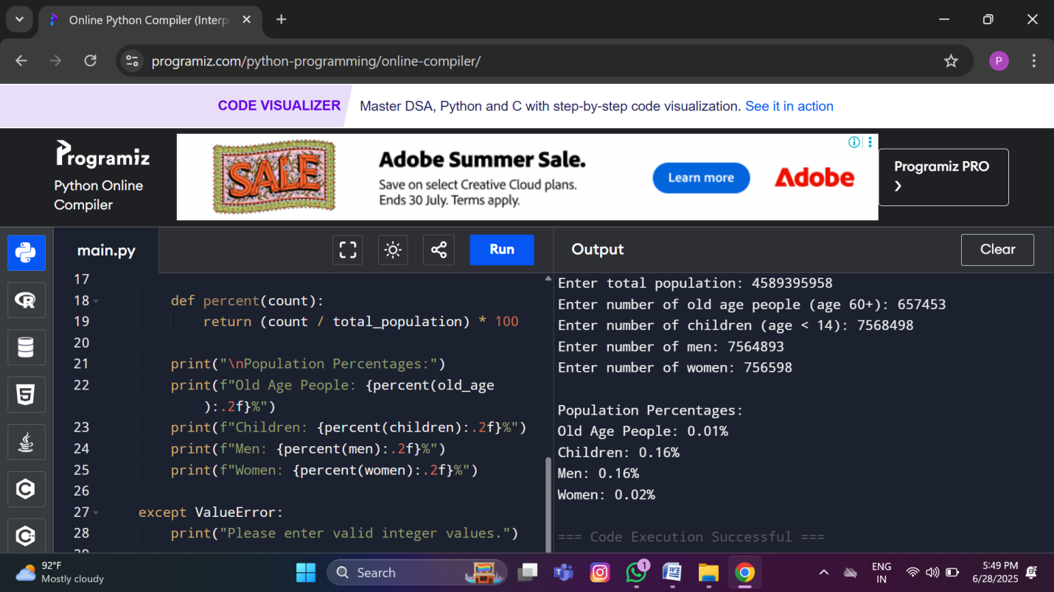

def calculate_detailed_demographics(people):

total = len(people)

if total == 0:

print("No data provided.")

return

men = women = boys = girls = old_men = old_women = 0

for person in people:

age = person.get("age")

gender = person.get("gender", "").lower()

if age is None or gender not in ["male", "female"]:

continue

if age < 14:

if gender == "male":

boys += 1

elif gender == "female":

girls += 1

elif age >= 60:

if gender == "male":

old_men += 1

elif gender == "female":

old_women += 1

else:

if gender == "male":

men += 1

elif gender == "female":

women += 1

def percent(count):

return (count / total) * 100

print(f"Total People: {total}")

print("\n=== Gender-based ===")

print(f"Men (14–59): {percent(men):.2f}%")

print(f"Women (14–59): {percent(women):.2f}%")

print("\n=== Children (age <14) ===")

print(f"Boys: {percent(boys):.2f}%")

print(f"Girls: {percent(girls):.2f}%")

print("\n=== Old Age (age 60+) ===")

print(f"Old Men: {percent(old_men):.2f}%")

print(f"Old Women: {percent(old_women):.2f}%")

# 🔍 Example Data

people = [

{"age": 8, "gender": "male"},

{"age": 10, "gender": "female"},

{"age": 35, "gender": "male"},

{"age": 45, "gender": "female"},

{"age": 63, "gender": "male"},

{"age": 71, "gender": "female"},

{"age": 13, "gender": "female"},

{"age": 60, "gender": "male"},

{"age": 30, "gender": "female"},

]

# ▶ Run the function

calculate_detailed_demographics(people)

